SHRI DHARMASTHALA MANJUNATHESHWARA COLLEGE (AUTONOMOUS), UJIRE - 574240

DEPARTMENT OF B.Voc
IN
SOFTWARE AND APPLICATION DEVELOPMENT
2024-2025


A PROJECT REPORT ON
“AREA CORPORATION SYSTEM”

SUBMITTED BY:

ACHAL B G | 221301
ASHARY R | 221305
MOKSHITH M C | 221327
SUDARSHAN N S | 221341

UNDER THE GUIDANCE OF
Ms. DEVIKA
DEPARTMENT OF B.Voc IN
SOFTWARE AND APPLICATION DEVELOPMENT

SHRI DHARMASTHALA MANJUNATHESHWARA COLLEGE
(AUTONOMOUS), UJIRE - 574240

DEPARTMENT OF B.Voc
IN
SOFTWARE AND APPLICATION DEVELOPMENT
2024-2025


Certificate for the approval of project report
This is to certify that following students of III year B.Voc Software and Application Development has satisfactorily completed the project “AREA CORPORATION SYSTEM” for the B.Voc Software and Application Development. Prescribed by the college during academic year 2024-25.

Team Members,

1. ACHAL B G
2. ASHRAY R
3. MOKSHITH M C
4. SUDARSHAN N S

 | (Ms. Devika) | (Prof. Vishwanatha P )
Head of the Department | Project Guide | Principal
Examiners
1
2

DECLARATION

We hereby declare that this project work entitled “AREA CORPORATION SYSTEM” has been prepared by us during the year 2024– 25 under the guidance of Ms. Devika Department of Software and Application Development, SDM College in the partial fulfilment of B.Voc degree prescribed by the college.
We also declare that this project is the outcome of our own efforts, that it has not been submitted to any other university for the award of any degree.

Team Members

ACHAL B G | 221301
ASHRAY R | 221305
MOKSHITH M C | 221327
SUDARSHAN N S | 221341

ACKNOWLEDGEMENT

We would like to thank our principal Prof. Vishwanatha P, for his support. We would like to thank HOD, Department of B.Voc in Software and application development, SDM College Ujire, for his valuable suggestions. We also like to thank Ms. Devika, for her guidance.

Team Members

ACHAL B G | 221301
ASHRAY R | 221305
MOKSHITH M C | 221327
SUDARSHAN N S | 221341

INDEX

SL.NO | TITLE | PAGE NO.
1. | Synopsis | 1
  - Title of the project
  - Description about the project
  - Project category
  - Project framework
2. | Introduction | 2
  - Objective
  - Scope
3. | Requirement Specification
 | - Project Study Area  - Software Requirement  - Tools and Technology  - Java Implementation  - React JS  - MySQL server  - VS Code  - Intellij IDEA | 3-6
4. | System Design Specification
 | - Design Approach  - Modules used in User panel Design  - Identification module description  - Admin  4.3.2 Corporator  4.3.3 Technician  4.3.4 User  - Use case diagram  - Admin  - Technician  - Corporator  - User | 7-17

  - DFD
  - ERD
  - Database Design
    - Introduction
    - Database used in the module Implementation
    - Pictorial representation of PBSA
My SQL database
5. | Snapshots | 18-28
6. | Source Code | 29-85
7. | Conclusion | 86
 | 7.1 Future Enhancement
8. | Bibliography | 87

CHAPTER - 1
SYNOPSIS

  - Title of the project:
“AREA CORPORATION SYSTEM”

  - Description about the project:
The main purpose of our project is to modernize the consumer complaint and grievance redressal system with a user-friendly mobile app for Android and iOS, enabling easy complaint submission and tracking for efficient resolution.

  - Project Category:
React based web application.

  - Project Framework:
Spring Boot.
CHAPTER - 2
INTRODUCTION

The traditional consumer complaint system relied on letters and forms, making it difficult to use. To improve this process and make it more user-friendly, we are developing a web application for consumer complaint and grievance redressal.
This system will provide an efficient way for consumers to submit complaints, track their status, and receive resolutions, ensuring a more transparent and responsive process.

  - Objective

The consumer complaint and grievance redressal system enhances the efficiency of handling complaints by making coordination, monitoring, tracking, and resolution more seamless. It enables prompt and specific retrieval of data, ensuring that relevant information is easily accessible when needed. The system is designed with flexibility, allowing it to adapt to changes in the environment and evolving user requirements.

  - Scope
The scope of Performance Based Self Appraisal is that the traditional PBSA was designed in the excel sheet and it is little bit difficult to use it. To update the traditional PBSA and to make it more user friendly we are developing a mobile application for PBSA.

CHAPTER - 3
REQUIREMENT SPECIFICATION

Requirements specification is a specification of software requirements and hardware requirements required to do the project Requirements analysis encompasses those tasks that go into determining the needs or conditions to meet for a new or altered product or project. Taking account of the possibly conflicting requirements of the various stakeholders, analyzing, documenting, validating and managing software or system requirements.

  - Hardware Requirements

SL. No | Hardware/Equipment | Specification
1 | RAM | 2GB
2 | Processor | Pentium 4+
3 | Hard Disk | Minimum of 80 GB
4 | Speed | - GHz+

3.2 Software Requirements

Sl. No | Software | Specification
1 | Operating System | Windows XP or Higher
2 | Language Used | Java
3 | IDE | Visual Studio code
4 | Database | MySQL Server

3.3 Tools and Technology

3.3.1 JAVA IMPLEMENTATIONS

Sun Microsystems officially licenses the Java Standard Edition platform for Linux, Mac OS X, and Solaris. Although in the past Sun has licensed Java to Microsoft, the license has expired and has not been renewed. Through a network of third-party vendors and licensees, alternative Java environments are available for these and other platforms.
Sun's trademark license for usage of the Java brand insists that all implementations be "compatible". This resulted in a legal dispute with Microsoft after Sun claimed that the Microsoft implementation did not support RMI or JNI and had added platform-specific features of their own. Sun sued in 1997 and in 2001 won a settlement of US$20 million, as well as a court order enforcing the terms of the license from Sun. As a result, Microsoft no longer ships Java with Windows, and in recent versions of Windows, Internet Explorer cannot support Java applets without a third-party plug-in. Sun, and others, have made available free Java run-time systems for those and other versions of Windows.

Platform-independent Java is essential to the Java EE strategy, and an even more rigorous validation is required to certify an implementation. This environment enables portable server-side applications, such as Web services, Java Servlets, and Enterprise JavaBeans, as well as with embedded systems based on OSGi, using Embedded Java environments. Through the new GlassFish project, Sun is working to create a fully functional, unified open source implementation of the Java EE technologies. Sun also distributes a super set of the JRE called the Java Development Kit (commonly known as the JDK), which includes development tools such as the Java compiler, Javadoc, Jar, and debugger.

3.3.2 REACT JS

React.js is a popular JavaScript library used for building dynamic and interactive user interfaces, especially for single-page applications. Developed and maintained by Facebook, React allows developers to create reusable UI components, making code more modular and efficient. It follows a declarative approach, enabling seamless updates and rendering of components as data changes. React’s virtual DOM enhances performance by minimizing direct manipulations of the actual DOM. It also supports state management, component-based architecture, and integration with various frameworks and libraries. With its flexibility and efficiency, React has become a preferred choice for web and mobile application development.
3.3.3 MySQL Server

Microsoft SQL Server is a full-featured relational database management system (RDBMS) that offers a variety of administrative tools to ease the burdens of database development, maintenance and administration. In this article, we'll cover six of the more frequently used tools: Enterprise Manager, Query Analyzer, SQL Profiler, Service Manager, Data Transformation Services and Books Online.
Enterprise Manager is the main administrative console for SQL Server installations. It provides you with a graphical "birds-eye" view of all of the SQL Server installations on your network. You can perform high-level administrative functions that affect one or more servers, schedule common maintenance tasks or create and modify the structure of individual databases.
Query Analyzer offers a quick and dirty method for performing queries against any of your SQL Server databases. It's a great way to quickly pull information out of a database in response to a user request, test queries before implementing them in other applications, create/modify stored procedures and execute administrative tasks.
SQL Profiler provides a window into the inner workings of your database. You can monitor many different event types and observe database performance in real time. SQL Profiler allows you to capture and replay system "traces" that log various activities. It's a great tool for optimizing databases with performance issues or troubleshooting particular problems

3.3.4 Visual Studio Code

Visual Studio Code (VS Code) is a lightweight yet powerful source code editor developed by Microsoft. It is widely used by developers for various programming languages, including JavaScript, Python, Java, C++, and more.
VS Code provides a feature-rich development environment with functionalities such as syntax highlighting, intelligent code completion, debugging, Git integration, and extensions to enhance productivity. Whether you are a beginner or an experienced developer, VS Code offers a seamless coding experience across different platforms.
As a tech enthusiast, having a basic understanding of VS Code can greatly improve your development workflow. In this article, we will guide you through the process of setting up and using Visual Studio Code on your computer.
3.3.5 Intellij IDEA

IntelliJ IDEA is a powerful and widely used integrated development environment (IDE) developed by JetBrains, designed primarily for Java development but also supporting multiple programming languages like Kotlin, Python, JavaScript, and more. It offers intelligent code completion, advanced debugging tools, and seamless integration with version control systems like Git. IntelliJ IDEA enhances productivity with features like refactoring, real-time code analysis, and a user-friendly interface. It supports various frameworks, including Spring, Hibernate, and React, making it ideal for full-stack development. With its robust performance and extensive plugin ecosystem, IntelliJ IDEA is a preferred choice for professional developers
CHAPTER - 4
SYSTEM DESIGN SPECIFICATION

4.1 Design Approach
This project is based on the functional design approach, which helps in understanding the design of the project in a simpler way by explaining its flow, use cases, and implementation more like a modular approach. For example, there are different modules in this project which have separate functionality and, other sub functionalities/modules. All the modules are designed, implemented and integrated together to make a flawless working web application.

  - Modules design

- Admin
- Corporator
- Technician
- User

4.3 Identification module description:

4.3.1 Admin

- Login
Admin can access this application by providing login details like username and password.
- Add area
Admin will be adding area details.
- Add technician category
Admin will be adding the technician details.
- Add area corporator
The area corporator details will be added by the admin.
- Approve User
Admin will approve user details.

4.3.2 Corporator

- Update Profile
Corporator edit the profile using this module.
- Change Password
Can change the password
- View user complaint

Corporator can view the status of the complaint.
- Task assign to respective technician

Corporator assign the task to respective technician based on the complaint.
- View status
Corporator can view the status of complaint.

    - Technician

- View task
Technician can view the task assigned to him.
- Update task
Technician can update the status of the task once completed.
- Incomplete task reason
Updates the reason for incomplete work.

    - User

- Registration
To access the application’s services users should first register to the application
- Login module
User can login by giving username and password and can make use of the application.
- Lodged complaint
User can lodged the complaint.
- View complaint process
User can view the status of complaint.

- Post Feedback
User can put his queries, comments or feedback to administrator for which admin answers.
- Logout
User can logout from the application.

4.4 Use case diagram:
The main aim of the system design is to explain the scenario using use case diagrams. Use case diagrams clarify the flow of the application by deriving the use cases for all the functionalities in form of diagrams for the students.
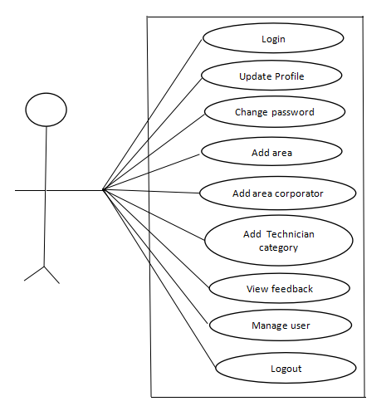

Figure 4.4.1 Admin

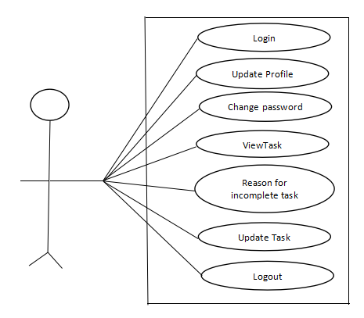

Figure 4.4.2 Technician

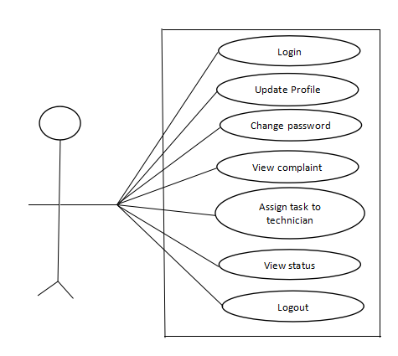

Figure 4.4.3 Corporator

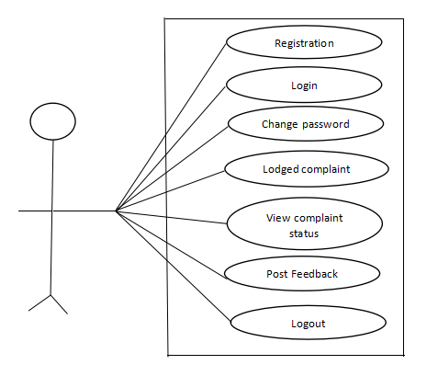

Figure 4.4.4 User
4.5 DATA FLOW DIAGRAM

A Data Flow Diagram (DFD) is a graphical representation of the flow of data through a system. It is used to visualize how data moves from input to output, how it is processed, and where it is stored. DFDs help in understanding system functions and designing efficient workflows.

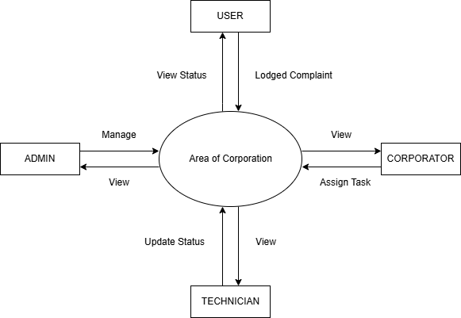

Figure 4.5.1

4.6 ENTITY RELATIONSHIP DIAGRAM

Entity Relationship Diagram (ERD) is a type of diagram used in database design that visually represents the structure of a database. It shows the entities (things you want to store information about), their attributes (details about those things), and the relationships between them.

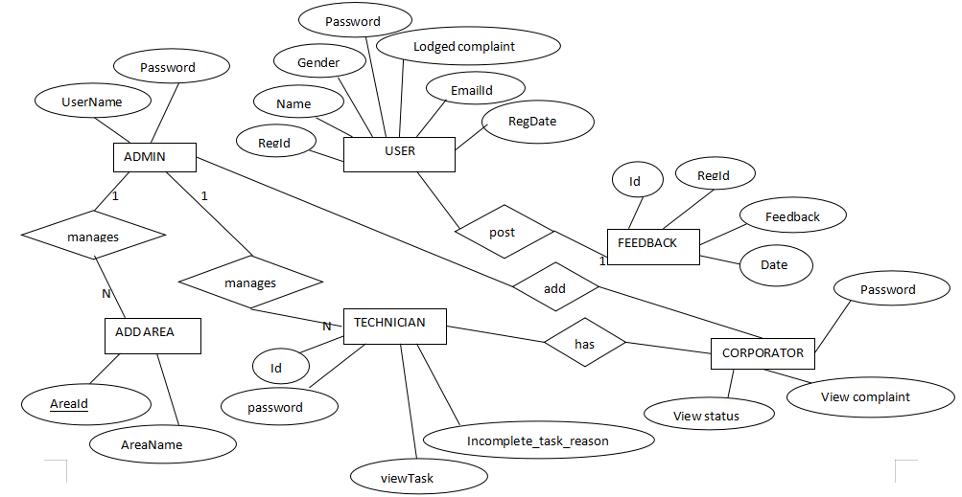

Figure 4.6.1
4.7 DATABASE DESIGN
4.7.1 Introduction
Database design is used to manage large bodies of information. The management of data involves both the definition of structure of storage and provision for the manipulation of information. In addition, the database system must provide the safety of the information solved despite system crashes or due to the attempts at unauthorized access. We have to fulfil certain conditions such as:
- Control Redundancy.
- Easy to use.
- Data Independence.
- Accuracy and Integrity.
- Recovery and Security.
- Performance

4.7.2 Database used in the module implementation
The system uses one database:
- MySQL
4.7.2.1 Implementation
Modules: Admin, Technician, Corporator, User

Admin:
        - Add Area
        - Add category
        - Add Corporator
        - Add Technician
        - View Work Progress

Corporator:
        - Assign Technicians
        - Monitor Work Progress

Technician :
        - Receive Assignments
        - Upload Work Progress
Resident :
- Register Complaints
- View Work Progress

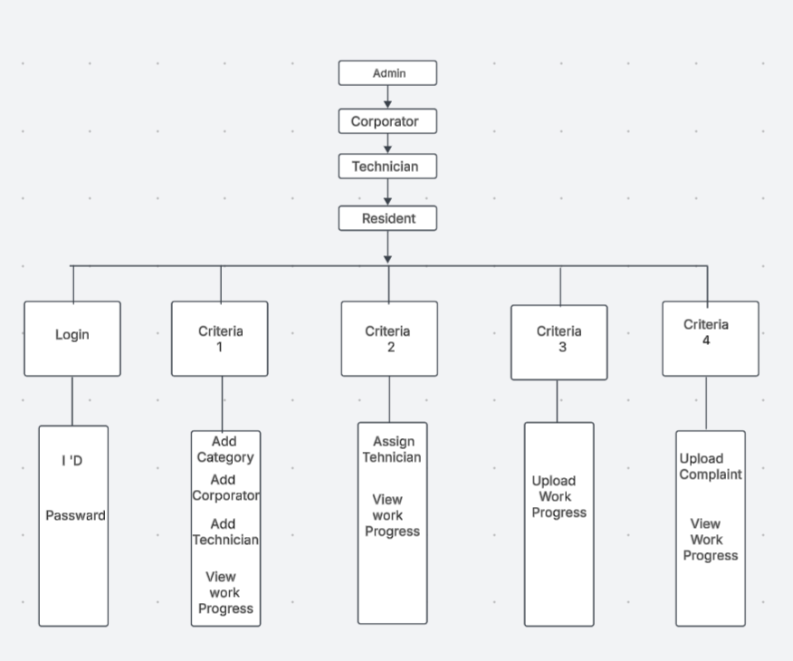
4.7.3 Pictorial representation of a PBSA MySQL database

CHAPTER - 5
SNAPSHOTS

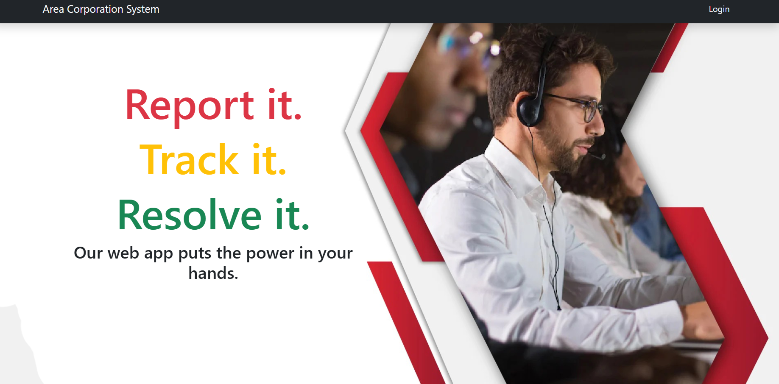
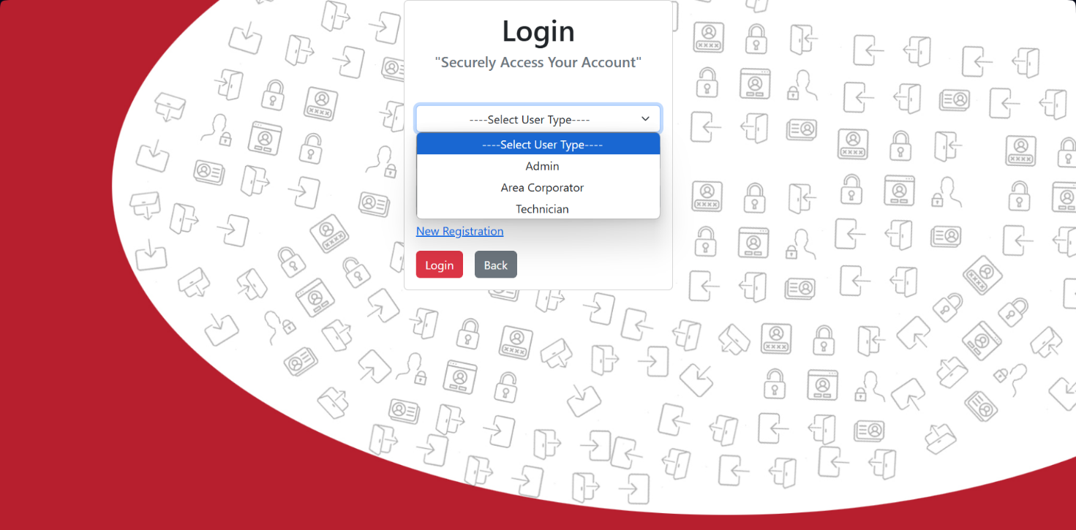

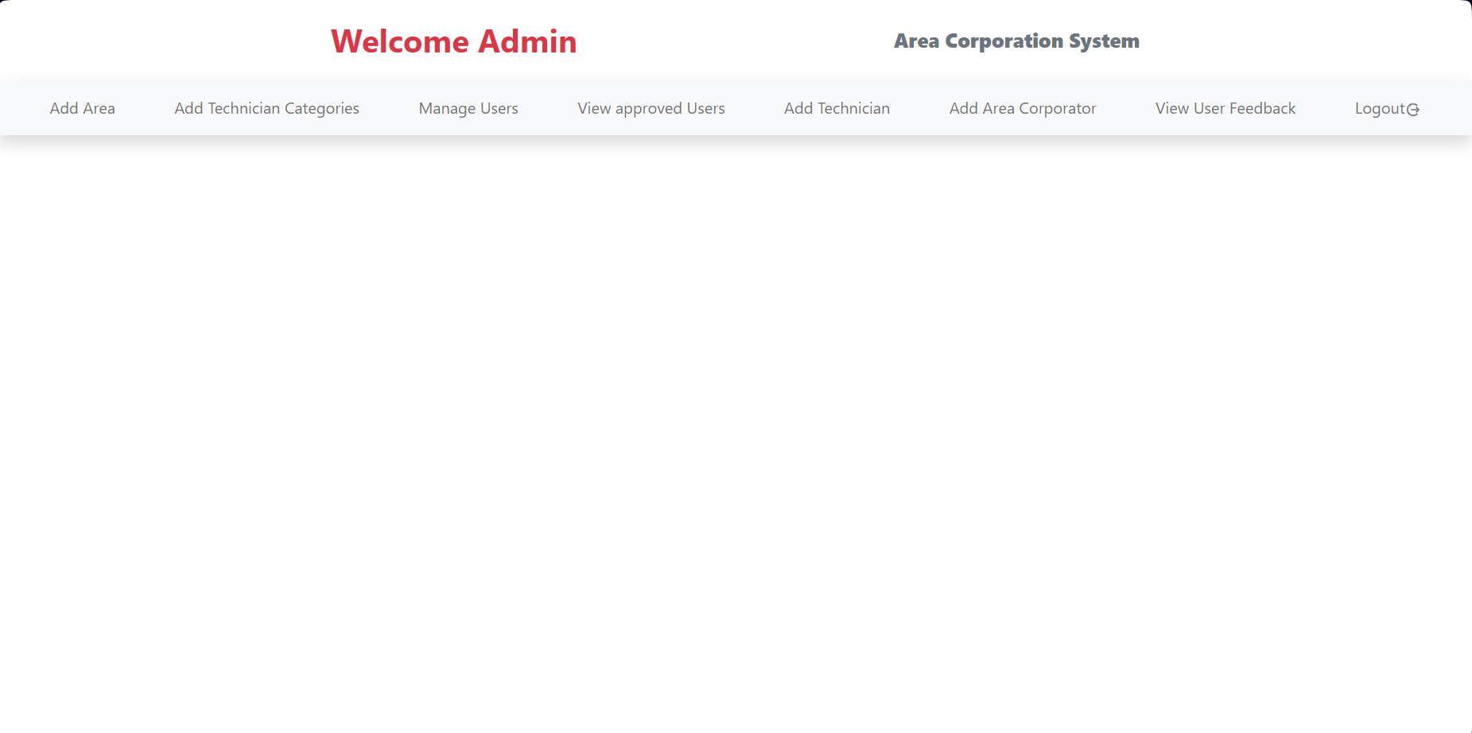
Admin

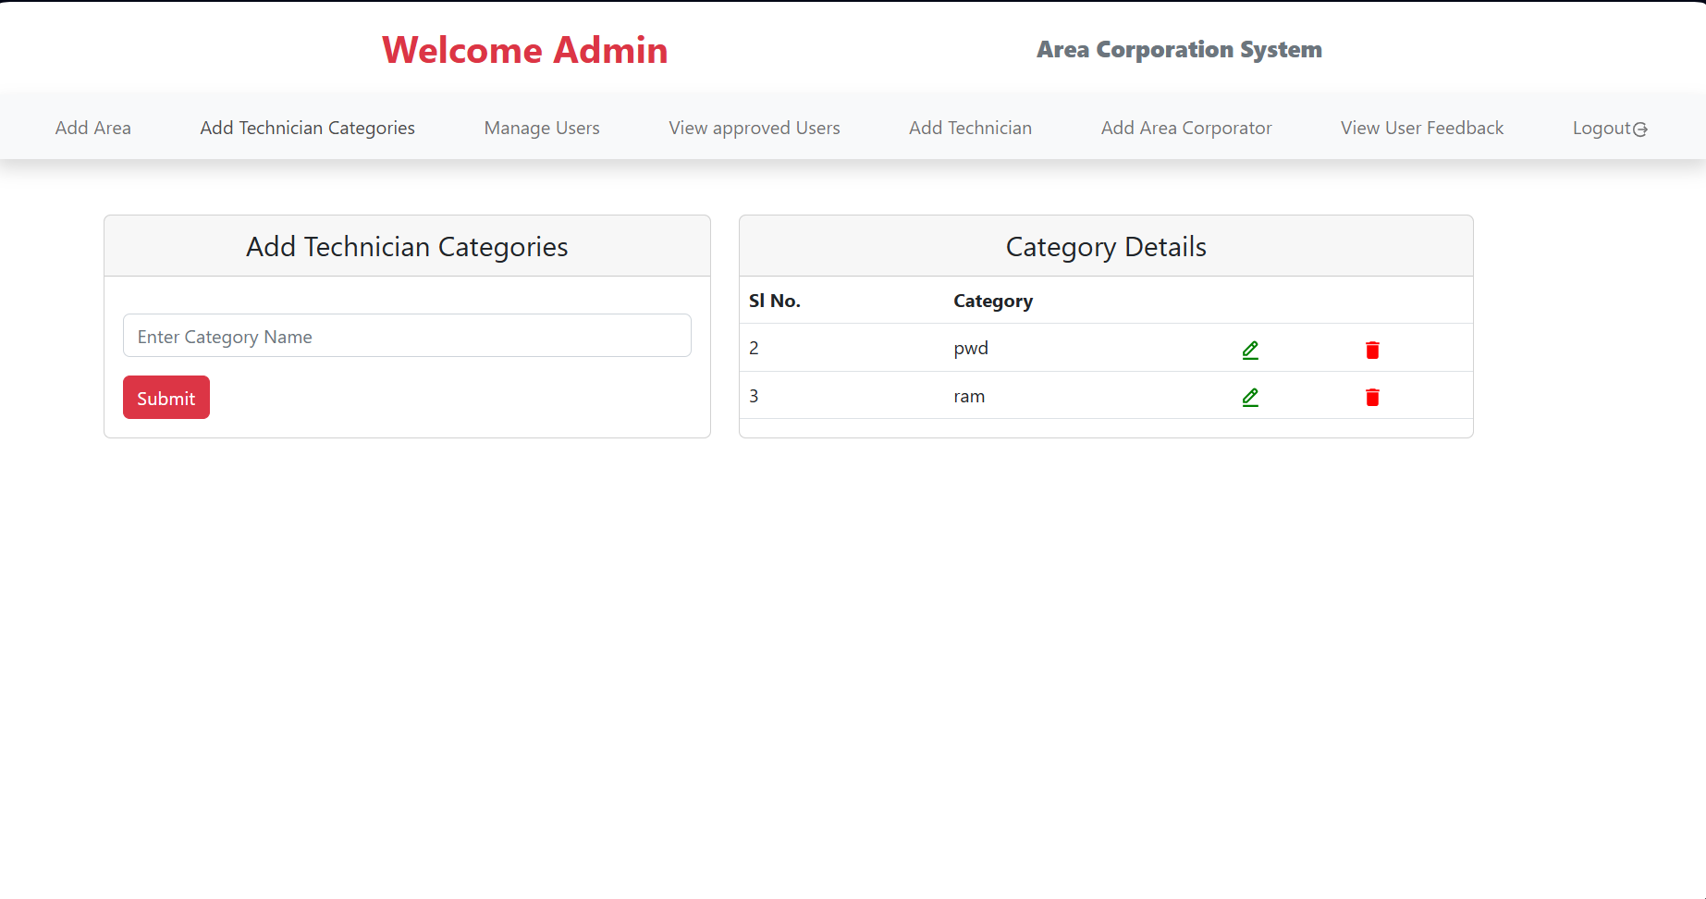
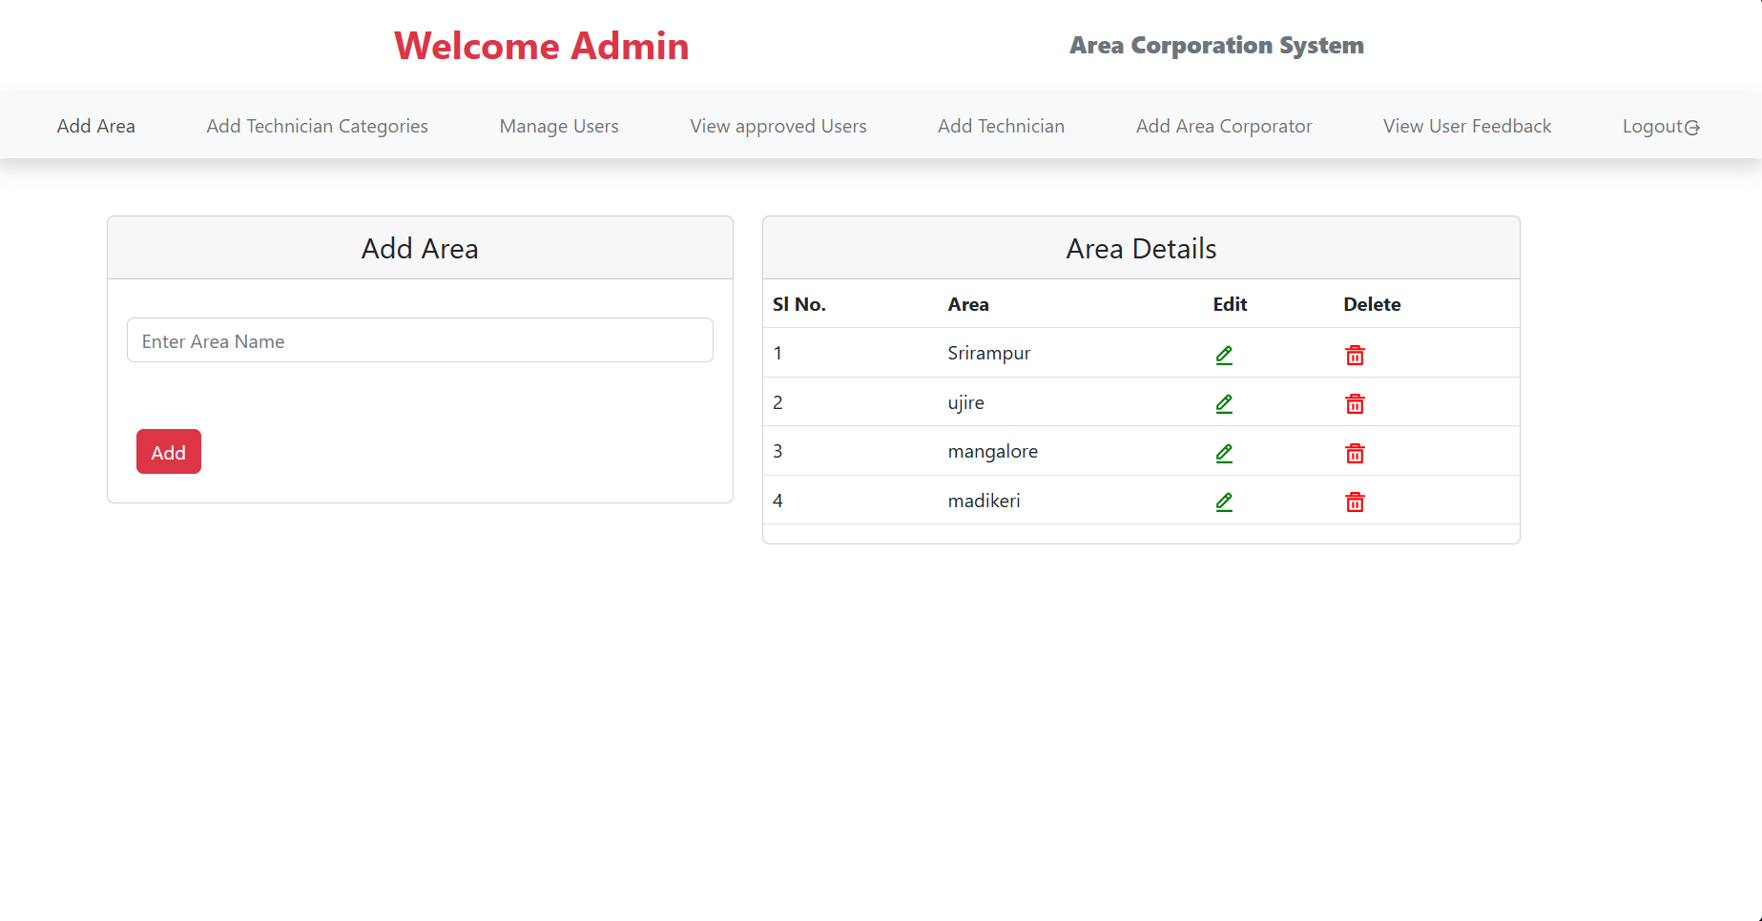
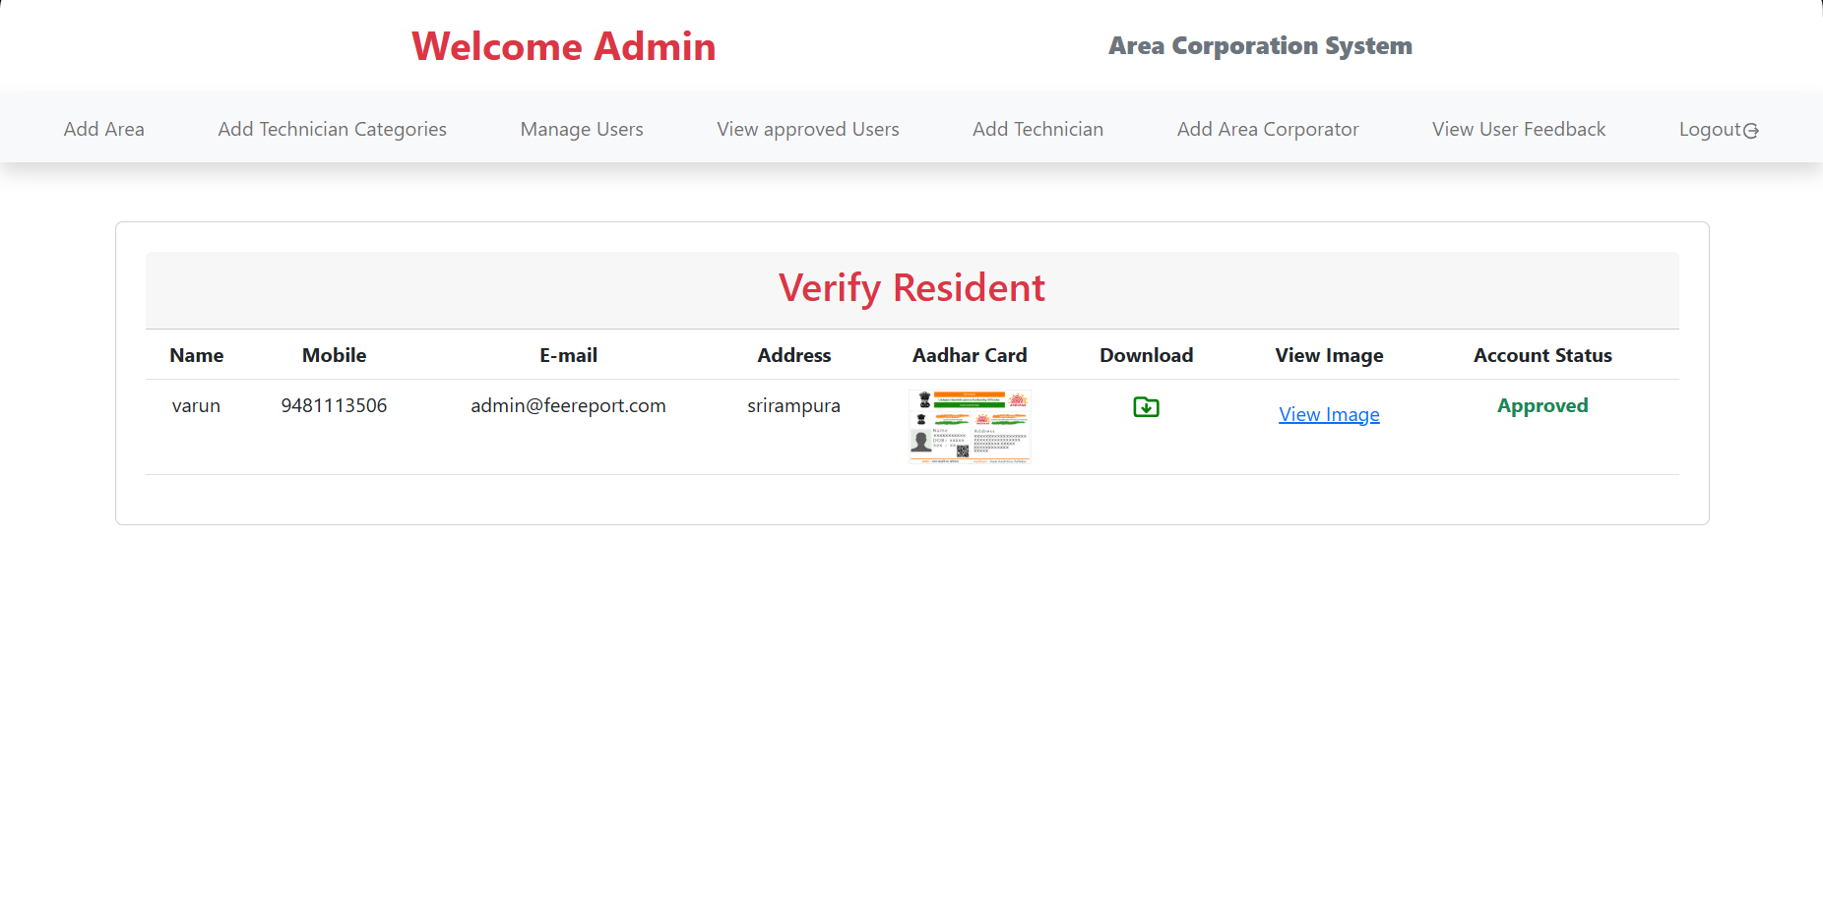

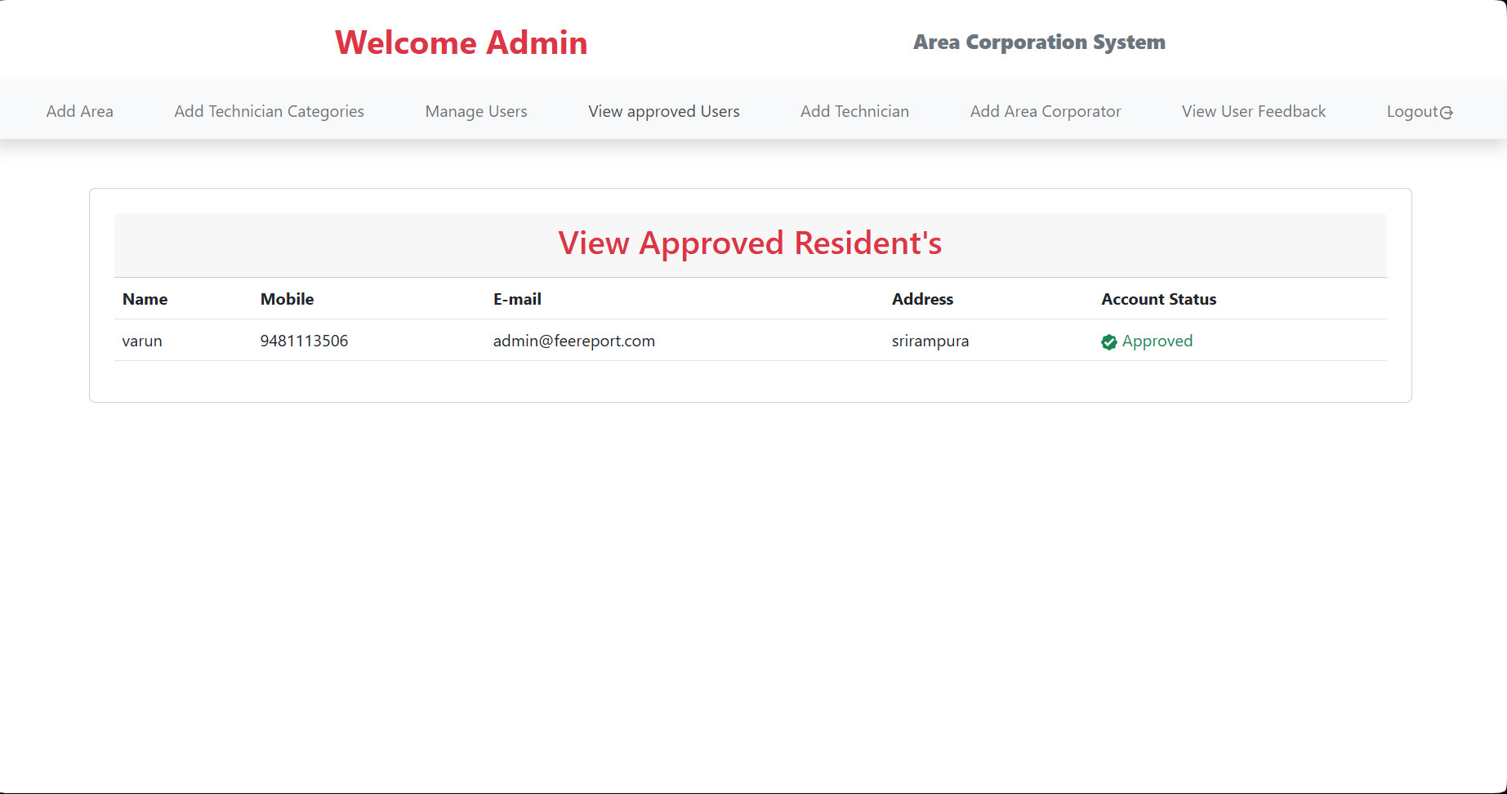

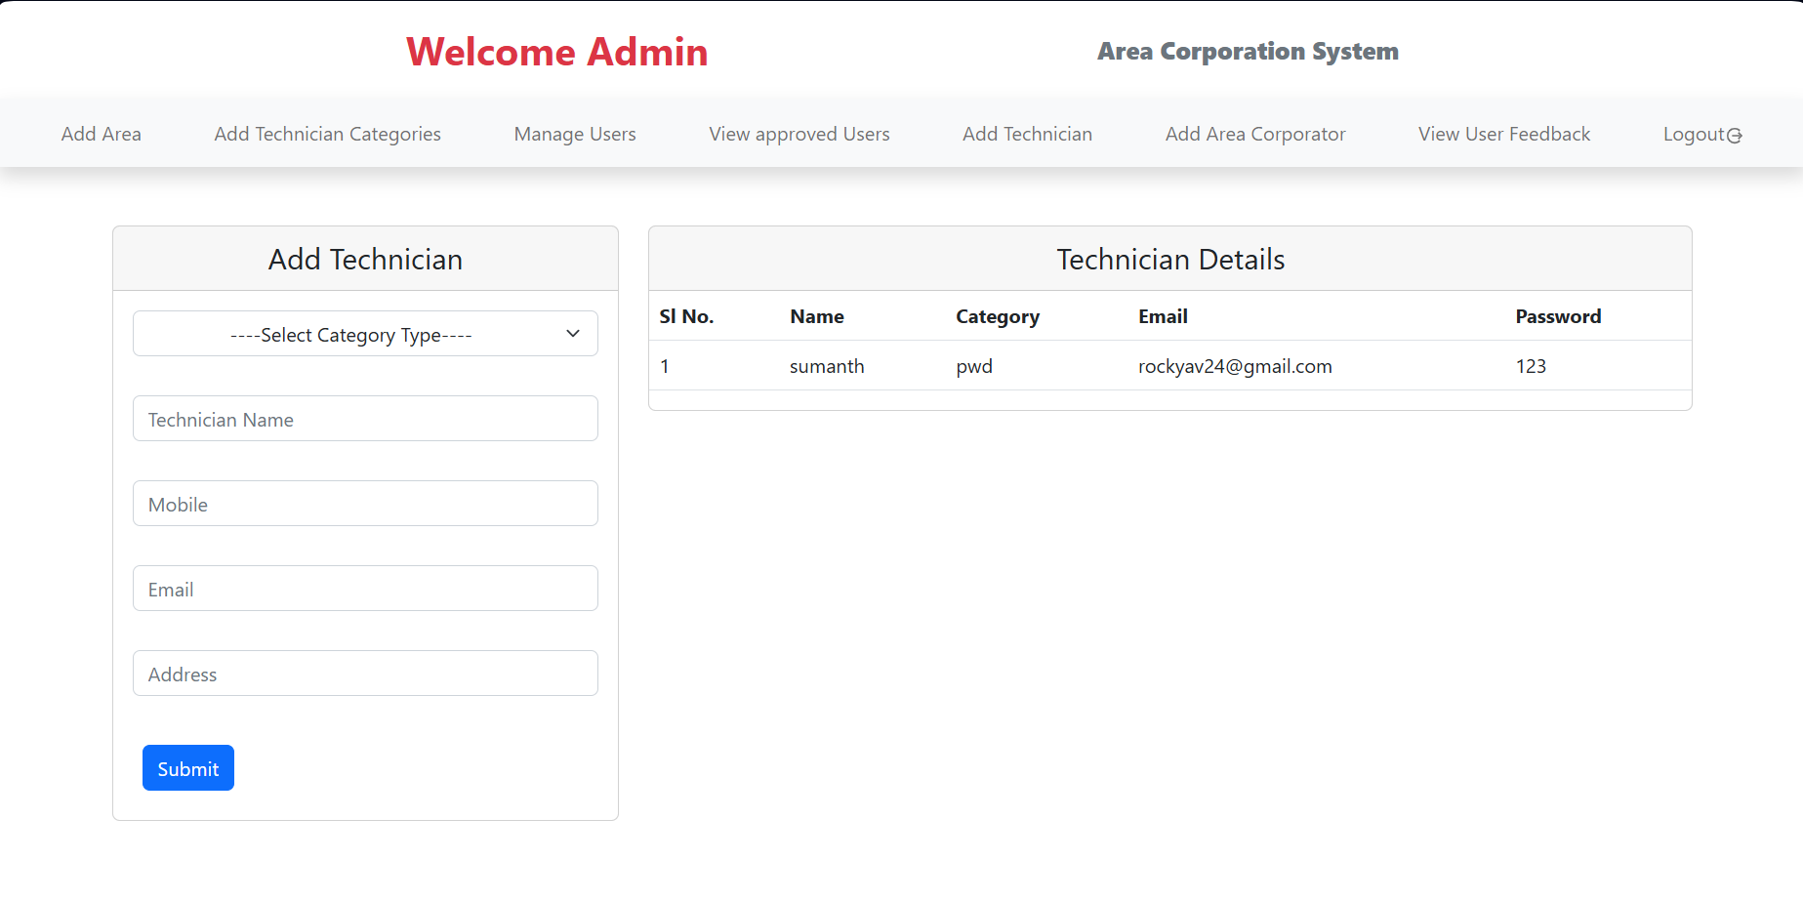

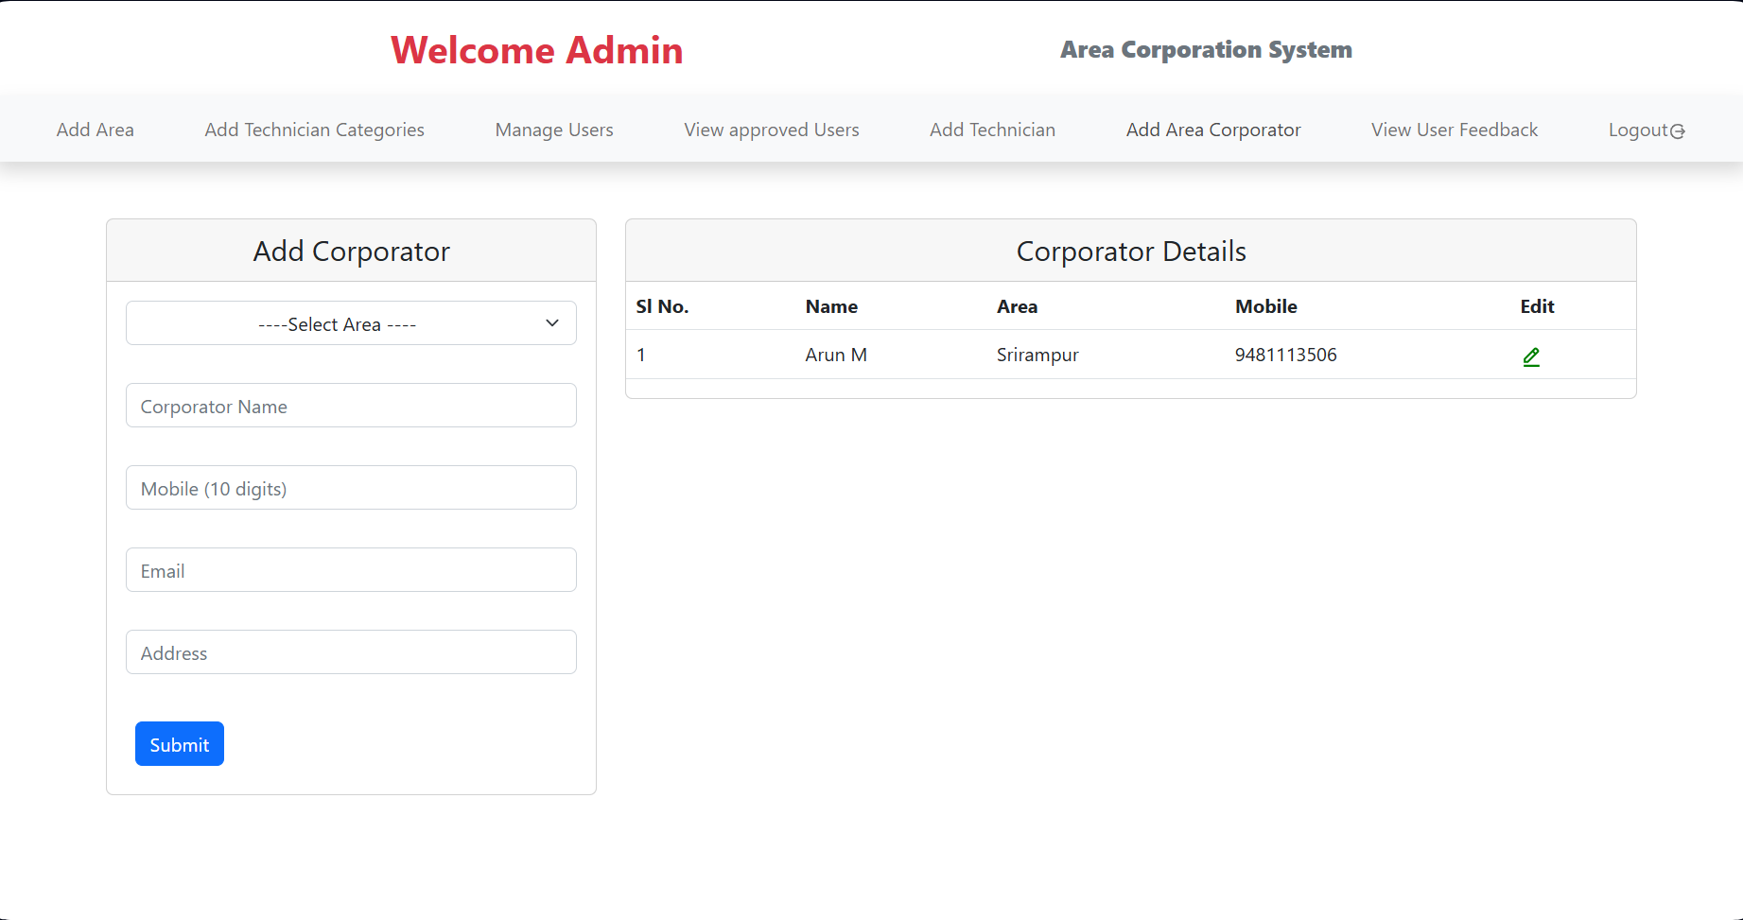

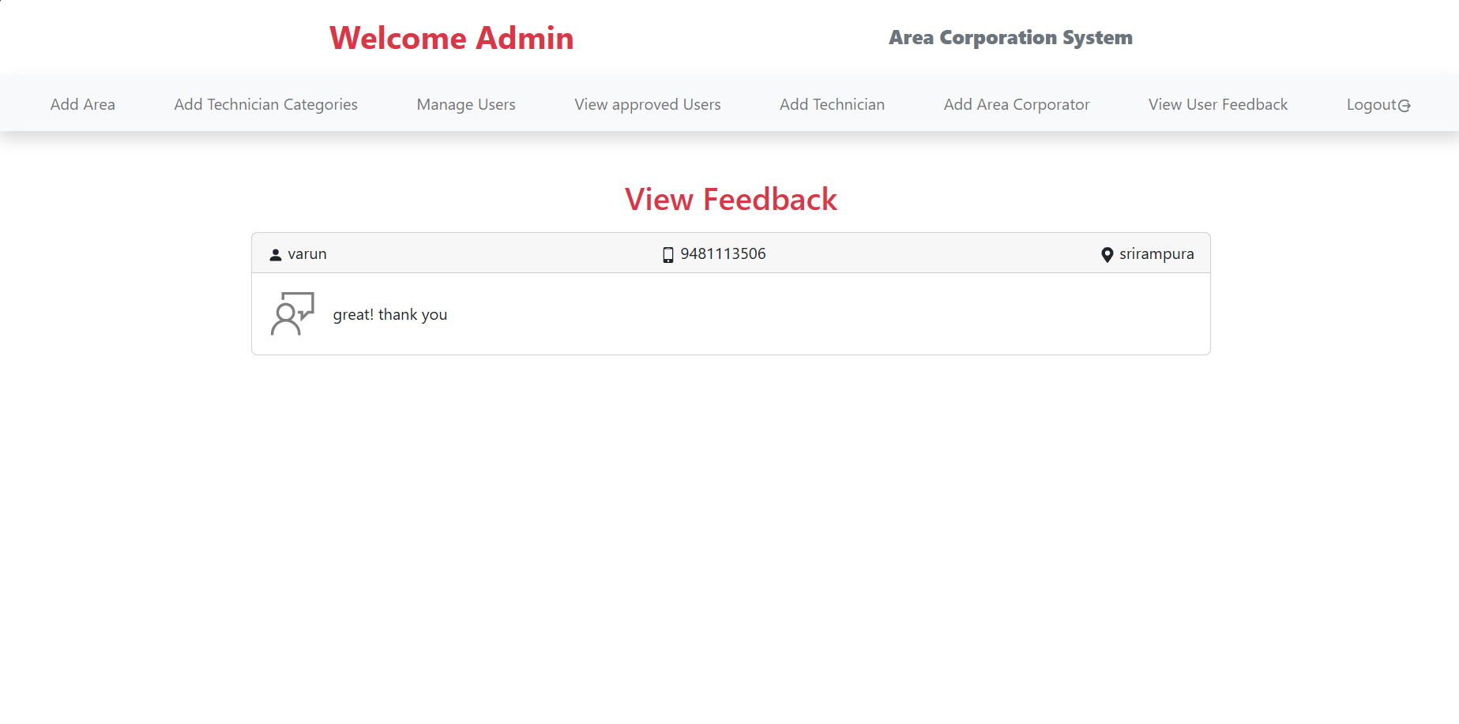

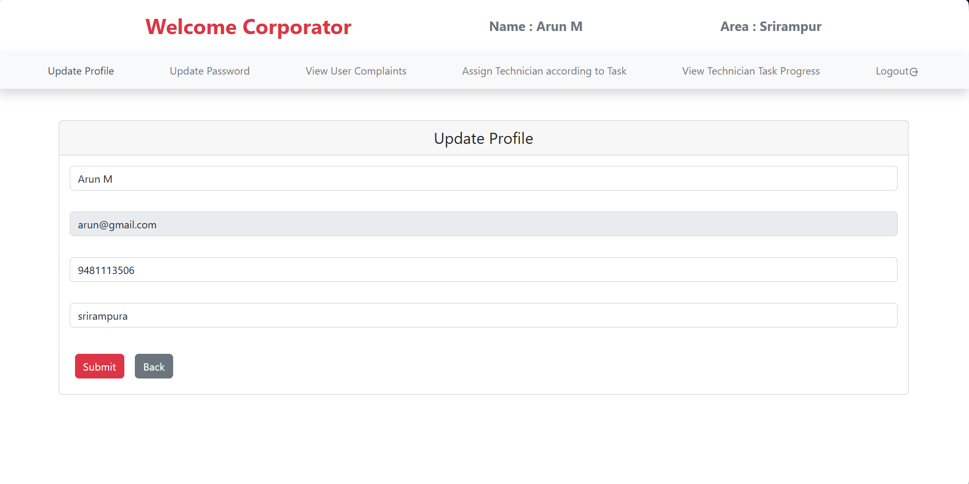
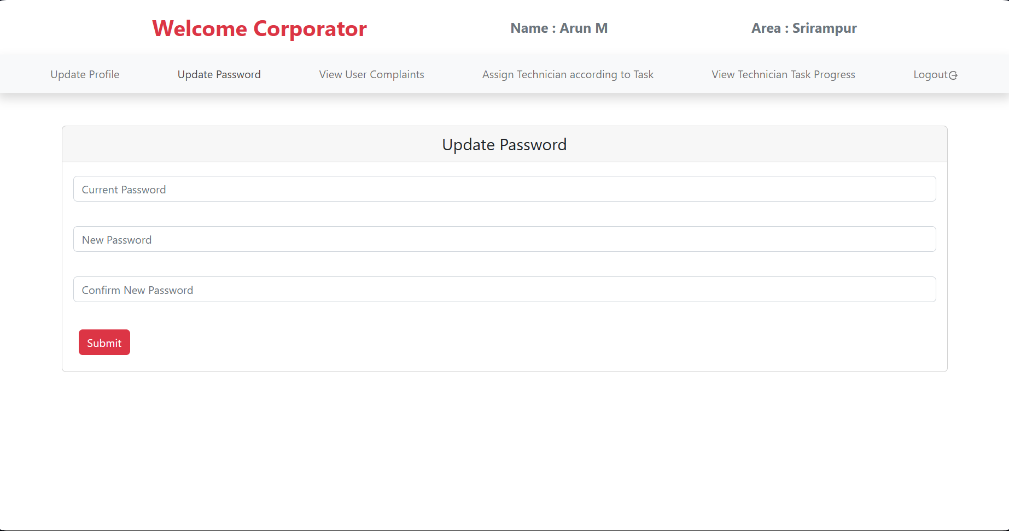
Corporator

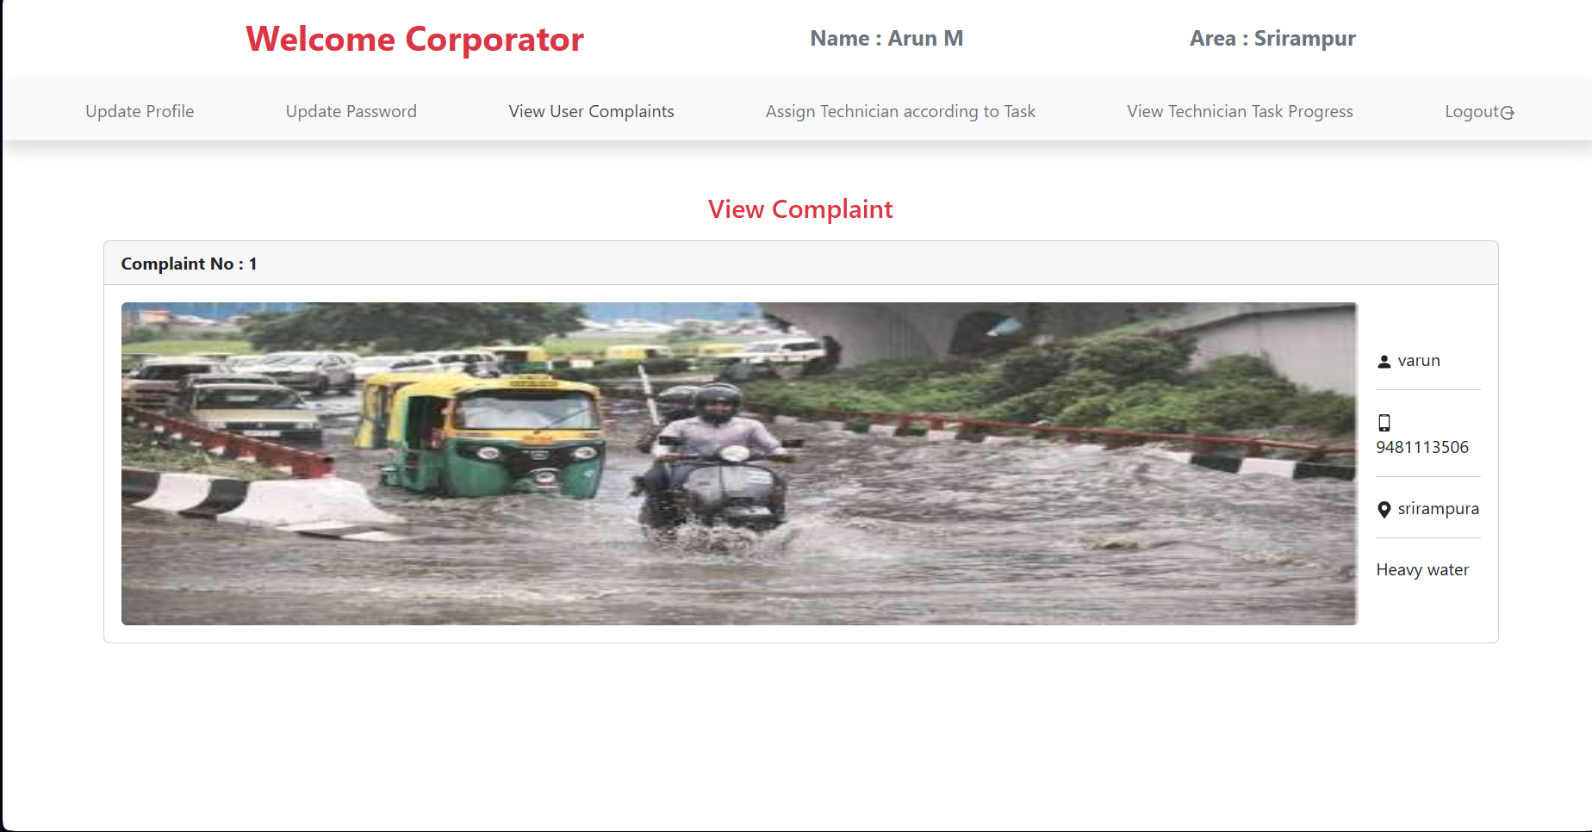

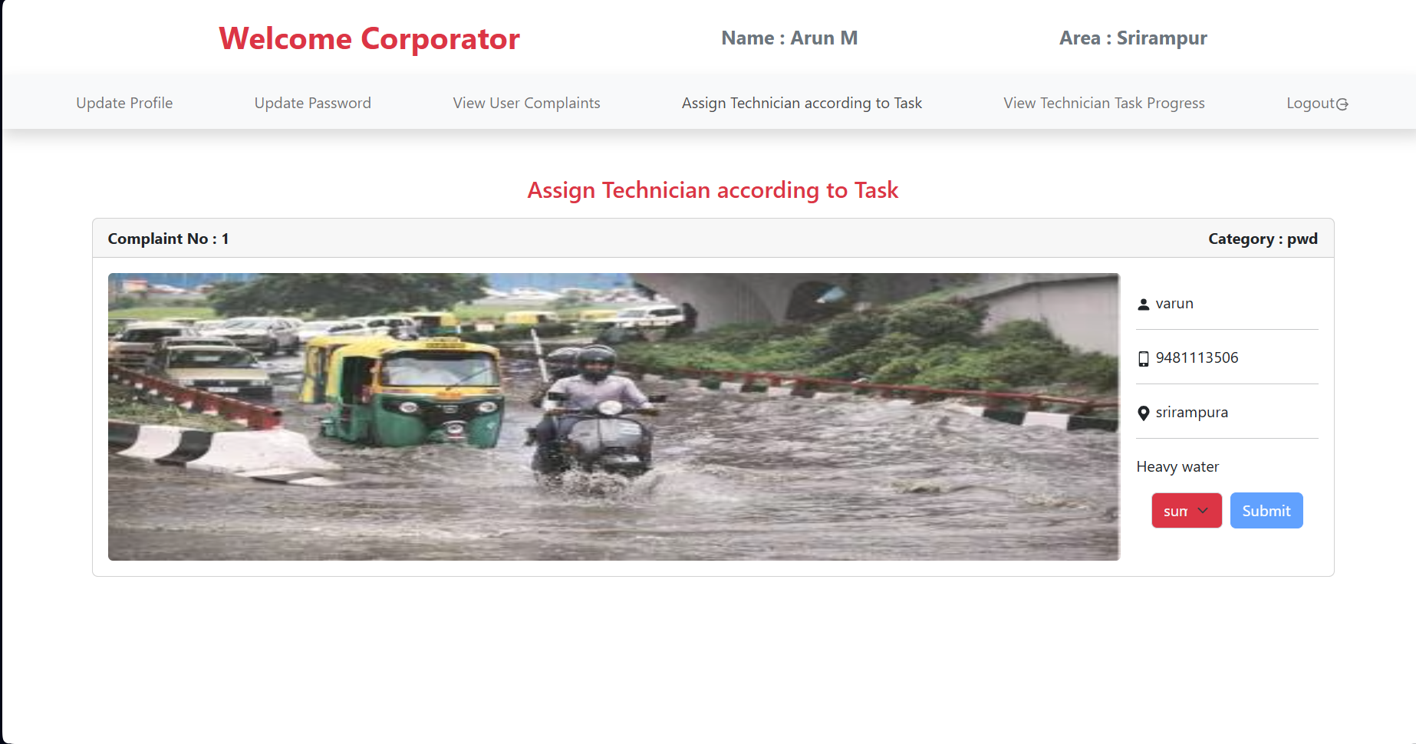

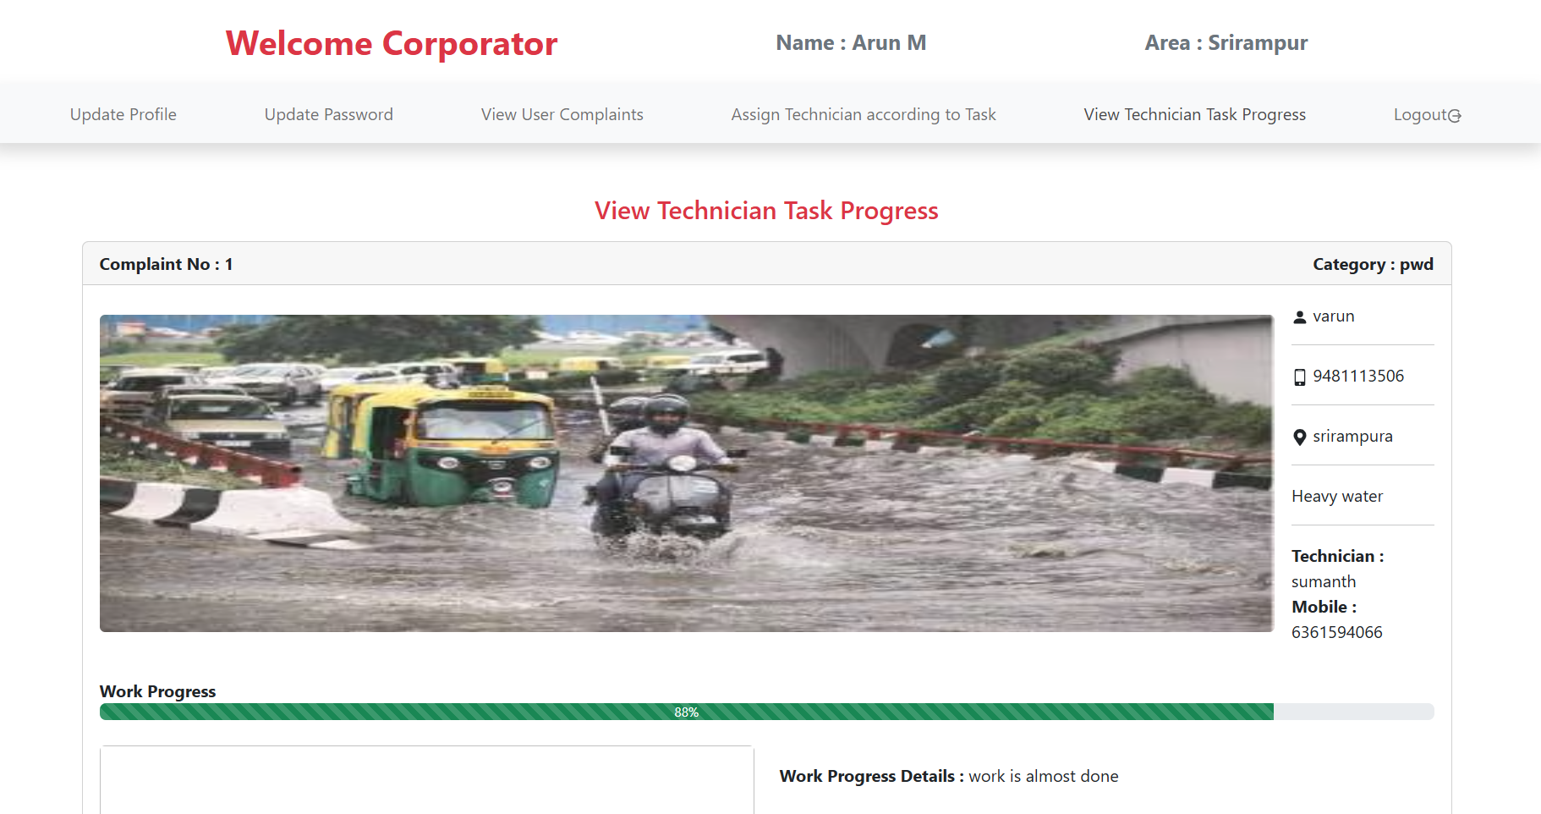

Technician

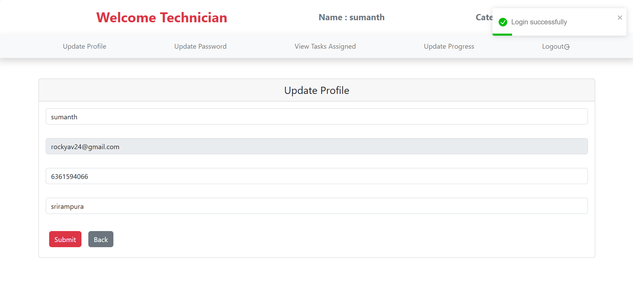

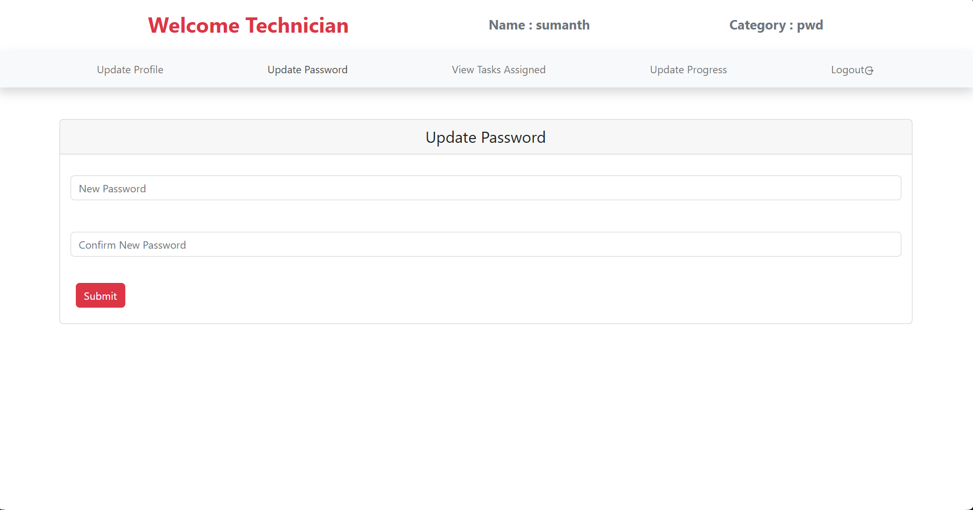

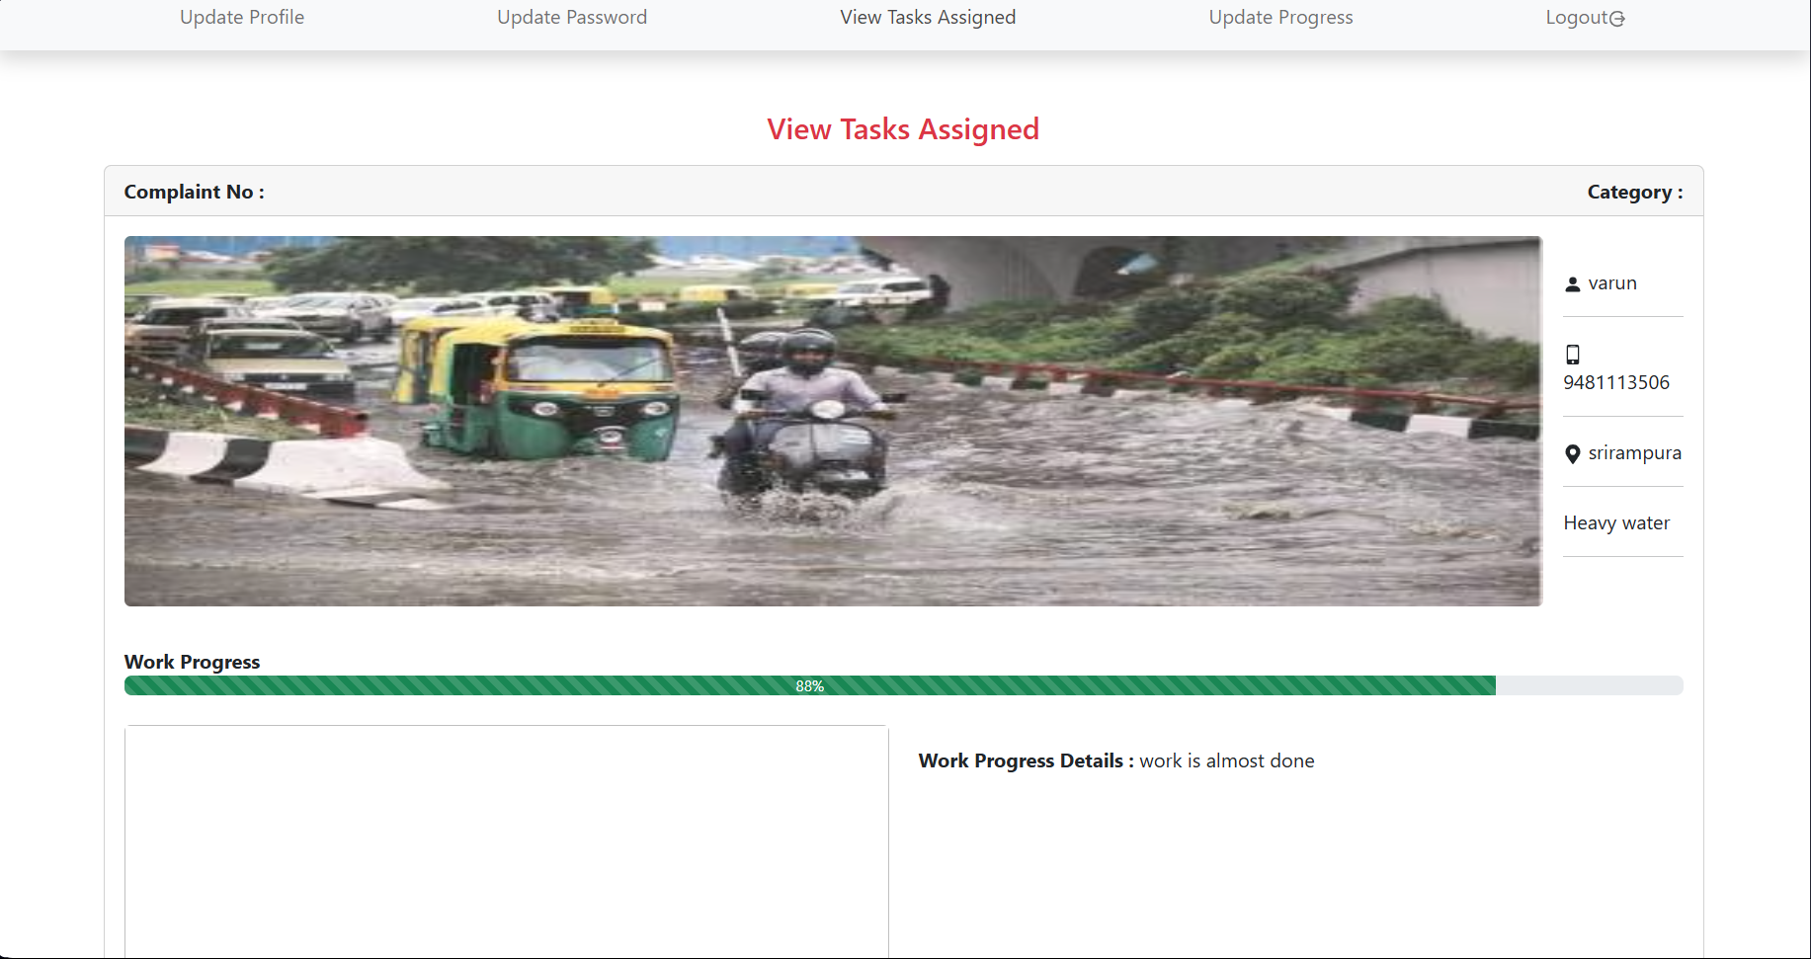

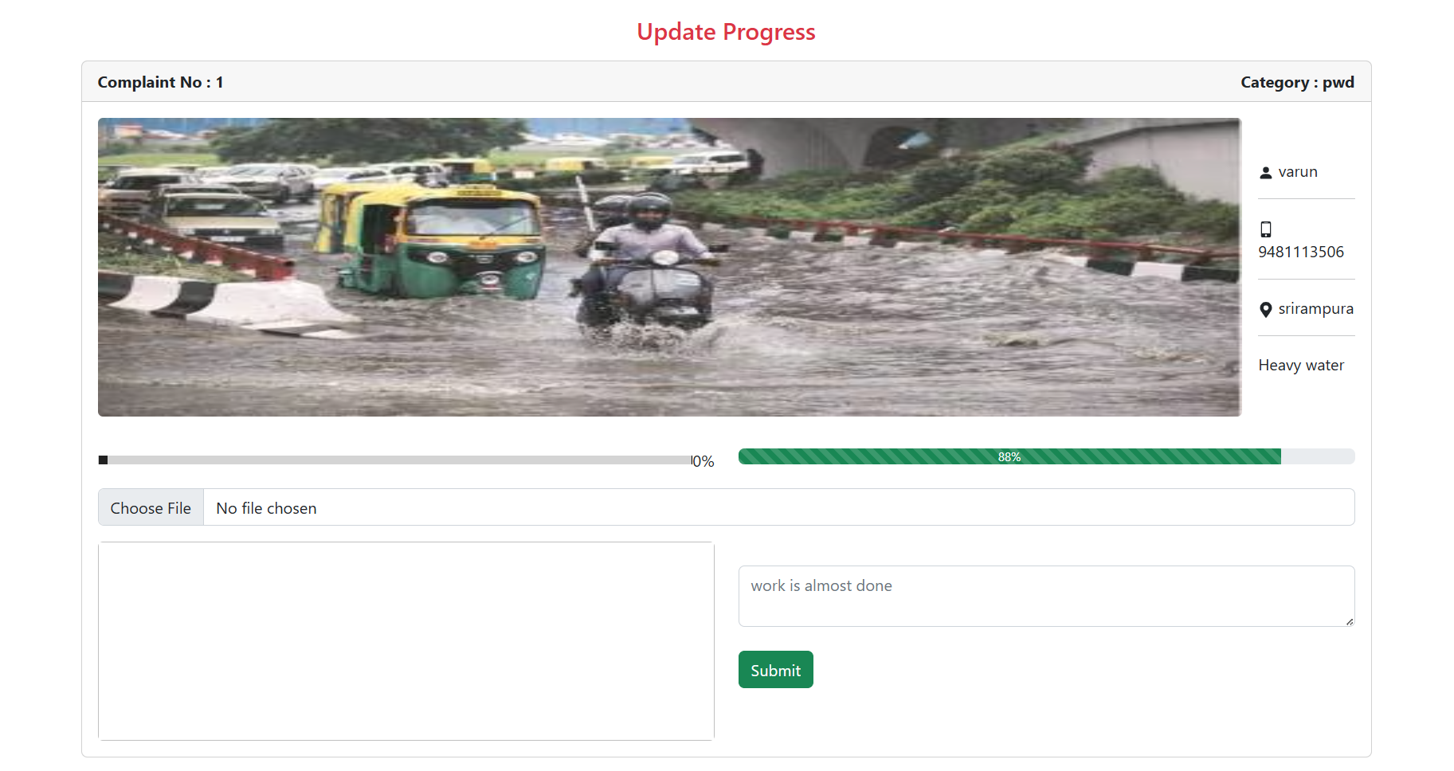

Resident

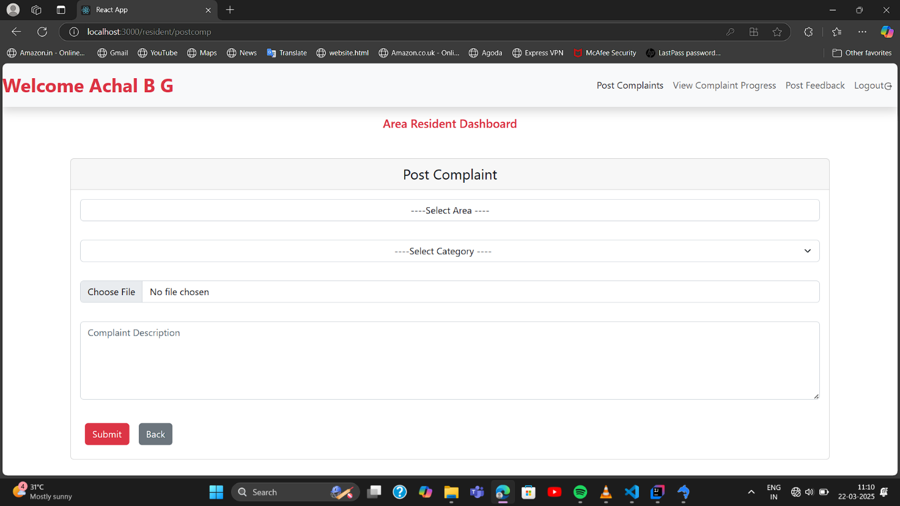

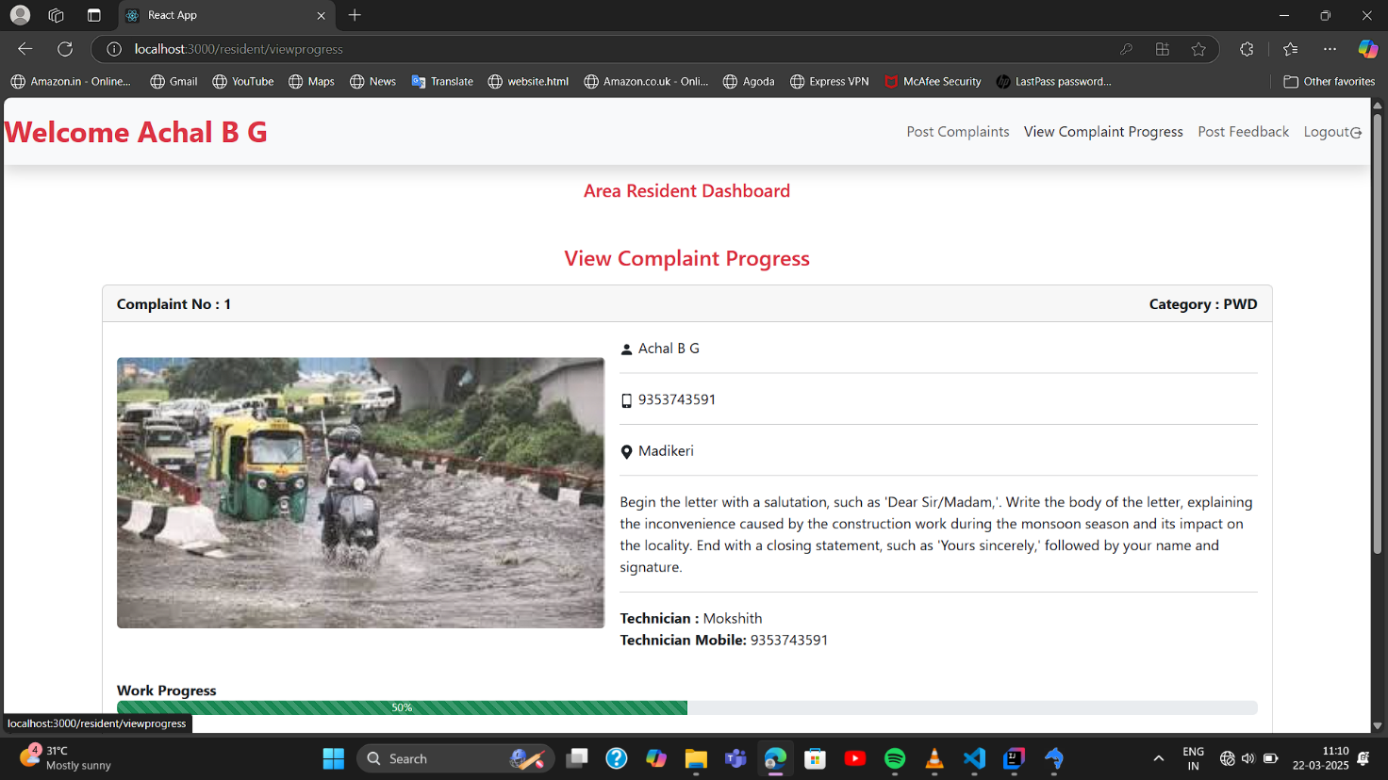

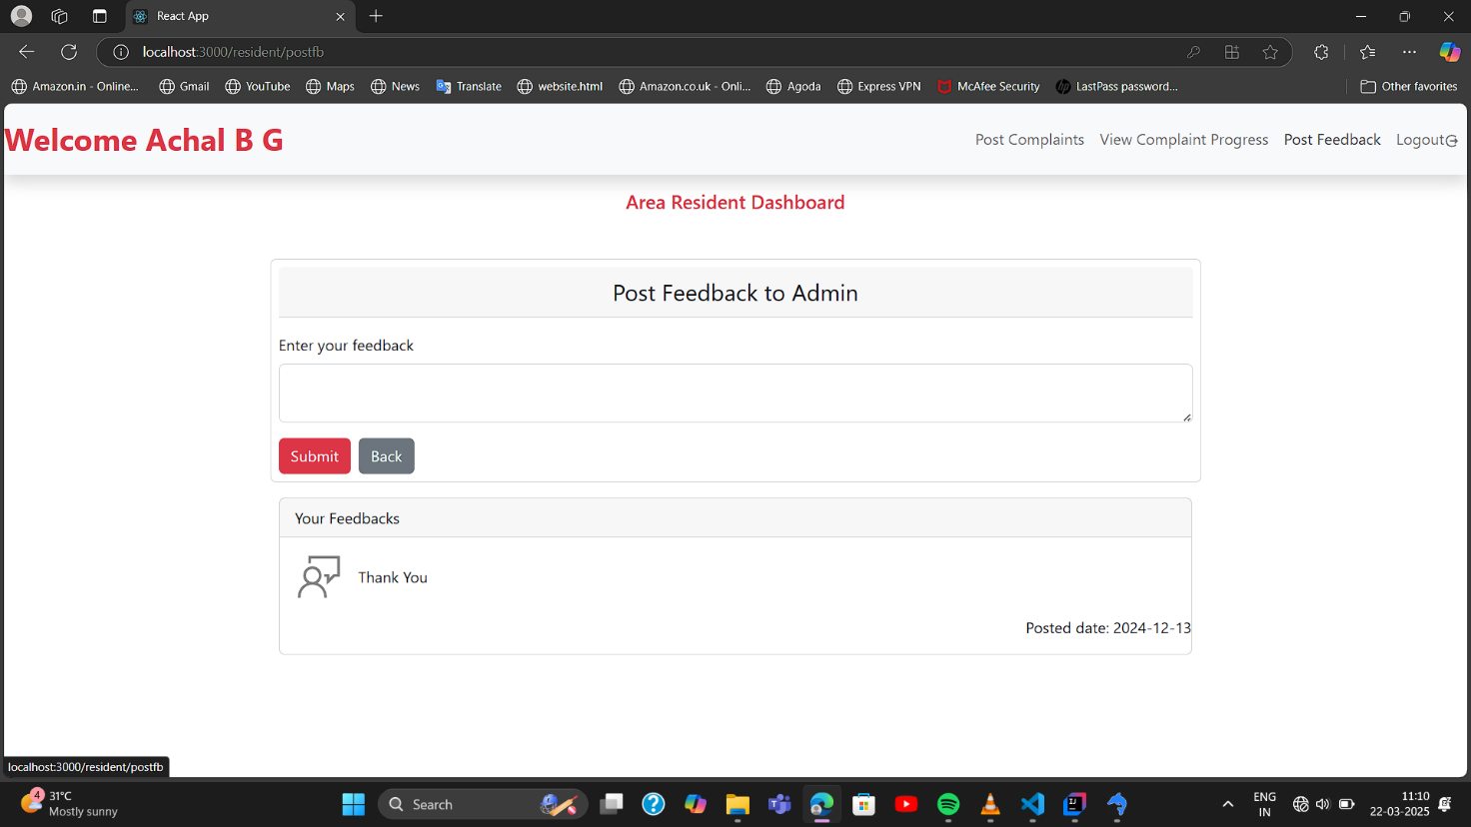

CHAPTER - 6
SOURCE CODE

Login.js

import axios from "axios";
import React, { useState } from "react";
import { Button, Card, Form } from "react-bootstrap";
import { Link, useNavigate } from "react-router-dom";
import { toast } from "react-toastify";

export default function Login() {
const navigate = useNavigate();

const users = ["Admin", "Area Corporator","Technician"," Area Resident"];

const [usertype, setUsertype] = useState("");
const [id, setId] = useState("");
const [password, setPassword] = useState("");

function handleLogin(e) {
e.preventDefault();
const obj = { id, password, usertype };
axios
.post("http://localhost:8080/Api/Corporation/UserLogin", obj)
.then((res) => {
if (res.data === "Admin") {
sessionStorage.setItem("admin", id);
navigate("/admin");
toast.success("Login successfully");
}
if (res.data === "Area Corporator") {
sessionStorage.setItem("corporator", id);
navigate("/corporator");
toast.success("Login successfully");
}
if (res.data === "Technician") {
sessionStorage.setItem("technician", id);
navigate("/technician");
toast.success("Login successfully");
}
if (res.data === "Area Resident") {
sessionStorage.setItem("resident", id);
navigate("/resident");
toast.success("Login successfully");
}
})
.catch((err) => {
console.log(err);
toast.error(err.response.data ? err.response.data : "Failed to login");
});
}
return (
<div className="bg-login">
<Card className="d-flex mx-auto w-25">
<Card.Body>
<Card.Title className="text-center ">
<h1 className="focus-in-contract-bck ">Login</h1>
<p className="text-secondary mb-5">
"Securely Access Your Account"
</p>
</Card.Title>
<Form onSubmit={handleLogin}>
<Card.Text>
<select
className="form-select mb-3 text-center"
value={usertype}
onChange={(e) => setUsertype(e.target.value)}
required
>
<option value={0}>----Select User Type----</option>
{users.map((element, index) => {
return (
<option key={index} value={element}>
{element}
</option>
);
})}
</select>
<input
type={"text"}
className="form-control mb-3"
value={id}
onChange={(e) => setId(e.target.value)}
placeholder="Enter User ID/ Email"
required
/>
<input
type={"password"}
className="form-control"
value={password}
onChange={(e) => setPassword(e.target.value)}
placeholder="Enter Password"
required
/>
</Card.Text>
<Link to="/reg">New Registration</Link>
<div className="d-flex gap-3 mt-3">
<Button className="btn btn-danger" type="submit">
Login
</Button>
<Button as={Link} className="btn btn-secondary" to="/">
Back
</Button>
</div>
</Form>
</Card.Body>
</Card>
</div>
);
}

Home.js
import React from "react";
import { Container, Nav, Navbar } from "react-bootstrap";
import { Link } from "react-router-dom";

export default function Home() {

return (
<div>
<Navbar className="shadow bg-dark">
<Container>
<Navbar.Brand className="text-light" >
Area Corporation System
</Navbar.Brand>
<Nav.Link as={Link} to="/login" className="text-light">Login</Nav.Link>
</Container>
</Navbar>
<div className="bg-image">
<div className="txt focus-in-contract-bck ">
<h2 className="text-danger tx">Report it.</h2>
<h2 className="text-warning tx">Track it.</h2>
<h2 className="text-success tx">Resolve it.</h2>
<h2>Our web app puts the power in your hands.</h2>
</div>
</div>
</div>
);
}

App.js

import { BrowserRouter, Route, Routes } from "react-router-dom";
import axios from "axios";
import { ToastContainer } from "react-toastify";

import "./App.css";
import Home from "./Home";
import Login from "./Login";
import Adashboard from "./Admin/Adashboard";
import Cdashboard from "./Corporator/Cdashboard";
import Tdashboard from "./Technician/Tdashboard";
import Register from "./Resident/Register";
import AddArea from "./Admin/AddArea";
import ManageUser from "./Admin/ManageUser";
import ViewAppvUser from "./Admin/ViewAppvUser";
import AddTechnician from "./Admin/AddTechnician";
import AddCorporator from "./Admin/AddCorporator";
import ViewFeeback from "./Admin/ViewFeeback";
import AddCategory from "./Admin/AddCategory";
import PostComplaints from "./Resident/PostComplaints";
import PostFeedback from "./Resident/PostFeedback";
import ViewComplaintProgress from "./Resident/ViewComplaintProgress";
import ResidentDashboard from "./Resident/ResidentDashboard";
import UpdateCorpPassword from "./Corporator/UpdateCorpPassword";
import UpdateCorpProfile from "./Corporator/UpdateCorpProfile";
import ViewComplaints from "./Corporator/ViewComplaints";
import AssignTechnician from "./Corporator/AssignTechnician";
import ViewProgress from "./Corporator/ViewProgress";
import UpdatePassword from "./Technician/UpdatePassword";
import UpdateProfile from "./Technician/UpdateProfile";
import UpdateProgress from "./Technician/UpdateProgress";
import ViewTasks from "./Technician/ViewTasks";

export const baseurl = "http://localhost:8080/Api/Corporation";

export const url = axios.create({
baseURL: baseurl,
});

function App() {
return (
<BrowserRouter>
<ToastContainer />
<Routes>
<Route path="/" element={<Home />} />
<Route path="/login" element={<Login />} />
<Route path="/reg" element={<Register />} />

<Route path="/admin" element={<Adashboard />}>
<Route path="addarea" element={<AddArea />} />
<Route path="addcat" element={<AddCategory />} />
<Route path="manageusers" element={<ManageUser />} />
<Route path="viewuser" element={<ViewAppvUser />} />
<Route path="addtech" element={<AddTechnician />} />
<Route path="addcorp" element={<AddCorporator />} />
<Route path="viewfb" element={<ViewFeeback />} />
</Route>

<Route path="/corporator" element={<Cdashboard />}>
<Route path="updateprofile" element={<UpdateCorpProfile />} />
<Route path="updatepassword" element={<UpdateCorpPassword />} />
<Route path="viewcomplaints" element={<ViewComplaints />} />
<Route path="assigntech" element={<AssignTechnician />} />
<Route path="taskprogress" element={<ViewProgress />} />
</Route>

<Route path="/technician" element={<Tdashboard />} >
<Route path="updatetechprofile" element={<UpdateProfile />} />
<Route path="updatetechpassword" element={<UpdatePassword />} />
<Route path="viewtasks" element={<ViewTasks />} />
<Route path="updateprogress" element={<UpdateProgress />} />
<Route path="taskprogress" element={<ViewProgress />} />
</Route>

<Route path="/resident" element={<ResidentDashboard />}>
<Route path="postcomp" element={<PostComplaints />} />
<Route path="viewprogress" element={<ViewComplaintProgress />} />
<Route path="postfb" element={<PostFeedback />} />
</Route>
</Routes>
</BrowserRouter>
);
}

export default App;
Admin

Adashboard.js

import { Nav, Navbar } from "react-bootstrap";
import { Link, Outlet, useNavigate } from "react-router-dom";
import {IoMdLogOut} from "react-icons/io"
import ErrorPage from "../ErrorPage";

function Adashboard() {

const admin = sessionStorage.getItem("admin")

const navigate = useNavigate()

function logOut(){
sessionStorage.clear()
navigate("/")
}

if(!admin){
return <ErrorPage/>
}

return (
<>
<Navbar.Brand className="d-flex p-3 justify-content-evenly w-100 align-items-center">
<div className="text-danger fs-2 fw-bold">Welcome Admin </div>
<div className="text-secondary fs-5 fw-bold"><b>Area Corporation System</b></div>
</Navbar.Brand>
<Navbar bg="light" variant="light" className='shadow '>
<Nav className="d-flex justify-content-evenly w-100 align-items-center ">
<Nav.Link as={Link} to="addarea">Add Area</Nav.Link>
<Nav.Link as={Link} to="addcat">Add Technician Categories</Nav.Link>
<Nav.Link as={Link} to="manageusers">Manage Users</Nav.Link>
<Nav.Link as={Link} to="viewuser">View approved Users</Nav.Link>
<Nav.Link as={Link} to="addtech">Add Technician</Nav.Link>
<Nav.Link as={Link} to="addcorp">Add Area Corporator</Nav.Link>
<Nav.Link as={Link} to="viewfb">View User Feedback</Nav.Link>
<Nav.Link as={Link} to="/" onClick={logOut}>Logout<IoMdLogOut/></Nav.Link>
</Nav>
</Navbar>
<Outlet />
</>

)
}

export default Adashboard;

AddArea.js
import axios from "axios";
import React, { useEffect, useState } from "react";
import { Button, Card, Col, Container, Row } from "react-bootstrap";
import { Form } from "react-bootstrap";
import { toast } from "react-toastify";
import { baseurl } from "../App";
import { BiEditAlt } from "react-icons/bi";
import { RiDeleteBin5Line } from "react-icons/ri";

export default function AddArea() {

const [area, setArea] = useState("");

const [aid, setAid] = useState("");

function clearAll(){
setAid("");
setArea("")
}

const [areas, setAreas] = useState([]);

useEffect(() => {
getArea();
},[]);

function handleClick(e) {
e.preventDefault();
axios
.post(baseurl + `/AddArea`, {area})
.then((res) => {
alert(res.data);
clearAll();
getArea();
})
.catch((err) => {
console.log(err);
alert( err.response.data ? err.response.data : "Error Occured!");
});
}

function getArea() {
axios
.get(baseurl + `/GetArea`)
.then((res) => {
setAreas(res.data);
})
.catch((err) => {
console.log(err);
});
}

function assignData(result){
setAid(result.aid);
setArea(result.area)
}

function editArea(e){
e.preventDefault()
const data={aid,area}
axios.put(baseurl+`/EditArea`,data)
.then((res)=>{
toast.success("Area name updated successfully");
clearAll()
getArea()
})
.catch(error=>{
console.log(error)
alert( error.response.data ? error.response.data : "Error Occured!");
})

}

function deleteArea(aid){
axios.delete(baseurl+`/DeleteArea/${aid}`)
.then(res=>{
alert("Area deleted successfully");
getArea()
clearAll()
})
.catch(error=>{
console.log(error)
})
}

return (
<Container>
<Row>
<Col md={5} className="mt-5">
<Form onSubmit={aid ? editArea: handleClick}>
<Card>
<Card.Header className="fs-4 text-center">Add Area</Card.Header>
<Form.Group className="my-3 p-3">
<Form.Control
type="text"
placeholder="Enter Area Name"
value={area}
onChange={(e) => setArea(e.target.value)}
required
/>
</Form.Group>
<div className="d-flex p-4">
<Button variant="danger" type="submit">
{aid ? "Update" : "Add"}
</Button>
</div>
</Card>
</Form>
</Col>
<Col md={6} className="mt-5">
<Card>
<Card.Header className="fs-4 text-center">Area Details</Card.Header>
<table className="table">
<thead>
<tr>
<th>Sl No.</th>
<th>Area</th>
<th>Edit</th>
<th>Delete</th>
</tr>
</thead>
<tbody>
{areas.map((result, index) => {
return (
<tr key={index}>
<td>{result.aid}</td>
<td>{result.area}</td>
<td>
<BiEditAlt onClick={()=>assignData(result)} color="green" size="20px"></BiEditAlt>
</td>
<td>
<RiDeleteBin5Line onClick={()=>deleteArea(result.aid)} color="red" size="20px"> </RiDeleteBin5Line>
</td>
</tr>
);
})}
</tbody>
</table>
</Card>
</Col>
</Row>
</Container>
);
}

AddCategory.js

import axios from "axios";
import React, { useEffect, useState } from "react";
import { Button, Card, Col, Container, Row } from "react-bootstrap";
import { Form } from "react-bootstrap";
import { toast } from "react-toastify";
import { baseurl } from "../App";
import { BiEditAlt } from "react-icons/bi";
import { MdDelete } from "react-icons/md";

export default function AddCategory() {

const [category, setCategory] = useState("");

const [cid, setCid] = useState("");

function clearAll(){
setCid("");
setCategory("")

}

const [categories, setCategories] = useState([]);

useEffect(() => {
getCategories();
},[]);

function handleClick(e) {
e.preventDefault();
axios
.post(baseurl + "/AddCat", {category})
.then((res) => {
alert("Category added successfully");
clearAll();
getCategories();
})
.catch((err) => {
toast.error(err.response.data ? err.response.data : "Failed")
console.log(err);
});
}

function getCategories() {
axios
.get(baseurl + "/GetCat")
.then((result) => {
setCategories(result.data);
})
.catch((error) => {
console.log(error);
});
}

function assignData(result){
setCid(result.cid);
setCategory(result.category)
}

function editCat(){
const data={
cid: cid,
category:category
}
axios.put(baseurl+"/EditCat",data)
.then(res=>{
alert("Category updated successfully");
clearAll()
getCategories()
})
.catch(error=>{
console.log(error)
})

}

function deleteCat(cid){
axios.delete(baseurl+`/DeleteCat/${cid}`)
.then(res=>{
toast.error("Category deleted successfully");
getCategories()
})
.catch(error=>{
console.log(error)
})
}

return (
<Container>
<Row>
<Col md={5} className="mt-5">
<Form onSubmit={cid ? editCat: handleClick}>
<Card >
<Card.Header className="fs-4 text-center">Add Technician Categories</Card.Header>
<Form.Group className="mt-3 p-3 ">
<Form.Control
type="text"
placeholder="Enter Category Name"
value={category}
onChange={(e) => setCategory(e.target.value)}
required
/>
<div className="mt-3">
<Button variant="danger" type="submit">
Submit
</Button>
</div>
</Form.Group>

</Card>
</Form>
</Col>
<Col md={6} className="mt-5">
<Card>
<Card.Header className="fs-4 text-center">Category Details</Card.Header>
<table className="table">
<thead>
<tr>
<th>Sl No.</th>
<th>Category</th>
<th></th>
<th></th>
</tr>
</thead>
<tbody>
{categories.map((result, index) => {
return (
<tr key={index}>
<td>{result.cid}</td>
<td>{result.category}</td>
<td>
<BiEditAlt onClick={()=>assignData(result)} color="green" size="20px"></BiEditAlt>
</td>
<td>
<MdDelete onClick={()=>deleteCat(result.cid)}color="red" size="20px"> </MdDelete>
</td>
</tr>
);
})}
</tbody>
</table>
</Card>
</Col>
</Row>
</Container>
);
}

AddCorporate.js

import axios from "axios";
import React, { useEffect, useState } from "react";
import { Button, Card, Col, Container, Row } from "react-bootstrap";
import { Form } from "react-bootstrap";
import { toast } from "react-toastify";
import { baseurl } from "../App";
import { BiEditAlt } from "react-icons/bi";
import { MdDelete } from "react-icons/md";

export default function AddCategory() {

const [category, setCategory] = useState("");

const [cid, setCid] = useState("");

function clearAll(){
setCid("");
setCategory("")

}

const [categories, setCategories] = useState([]);

useEffect(() => {
getCategories();
},[]);

function handleClick(e) {
e.preventDefault();
axios
.post(baseurl + "/AddCat", {category})
.then((res) => {
alert("Category added successfully");
clearAll();
getCategories();
})
.catch((err) => {
toast.error(err.response.data ? err.response.data : "Failed")
console.log(err);
});
}

function getCategories() {
axios
.get(baseurl + "/GetCat")
.then((result) => {
setCategories(result.data);
})
.catch((error) => {
console.log(error);
});
}

function assignData(result){
setCid(result.cid);
setCategory(result.category)
}

function editCat(){
const data={
cid: cid,
category:category
}
axios.put(baseurl+"/EditCat",data)
.then(res=>{
alert("Category updated successfully");
clearAll()
getCategories()
})
.catch(error=>{
console.log(error)
})

}

function deleteCat(cid){
axios.delete(baseurl+`/DeleteCat/${cid}`)
.then(res=>{
toast.error("Category deleted successfully");
getCategories()
})
.catch(error=>{
console.log(error)
})
}

return (
<Container>
<Row>
<Col md={5} className="mt-5">
<Form onSubmit={cid ? editCat: handleClick}>
<Card >
<Card.Header className="fs-4 text-center">Add Technician Categories</Card.Header>
<Form.Group className="mt-3 p-3 ">
<Form.Control
type="text"
placeholder="Enter Category Name"
value={category}
onChange={(e) => setCategory(e.target.value)}
required
/>
<div className="mt-3">
<Button variant="danger" type="submit">
Submit
</Button>
</div>
</Form.Group>

</Card>
</Form>
</Col>
<Col md={6} className="mt-5">
<Card>
<Card.Header className="fs-4 text-center">Category Details</Card.Header>
<table className="table">
<thead>
<tr>
<th>Sl No.</th>
<th>Category</th>
<th></th>
<th></th>
</tr>
</thead>
<tbody>
{categories.map((result, index) => {
return (
<tr key={index}>
<td>{result.cid}</td>
<td>{result.category}</td>
<td>
<BiEditAlt onClick={()=>assignData(result)} color="green" size="20px"></BiEditAlt>
</td>
<td>
<MdDelete onClick={()=>deleteCat(result.cid)}color="red" size="20px"> </MdDelete>
</td>
</tr>
);
})}
</tbody>
</table>
</Card>
</Col>
</Row>
</Container>
);
}

AddTechnician.js

import axios from "axios";
import React, { useEffect, useState } from "react";
import { Button, Card, Col, Container, Row } from "react-bootstrap";
import { Form } from "react-bootstrap";
import { toast } from "react-toastify";
import { baseurl } from "../App";

export default function AddTechnician() {

const [cid, setCid] = useState("");

const [input, setInput] = useState({
name: "",
mobile: "",
email: "",
address: "",
});

const [categories, setCategories] = useState([]);

const [technician, setTechnician] = useState([]);

function handleChange(e) {
setInput((previous) => {
return { ...previous, [e.target.name]: e.target.value };
});
}

useEffect(() => {
getCategory();
getTech();
},[]);

function handleClick(e) {
e.preventDefault();
axios
.post(baseurl + `/AddTech/${cid}`, input)
.then((res) => {
clearInput()
toast.success("Technician added successfully");
getTech();
})
.catch((err) => {
console.log(err);
alert( err.response.data ? err.response.data : "Error Occured!");
});
}

function getCategory() {
axios
.get(baseurl + "/GetCat")
.then((res) => {
setCategories(res.data);
})
.catch((err) => {
console.log(err);
});
}

function getTech() {
axios
.get(baseurl + "/GetTech")
.then((res) => {
setTechnician(res.data);
console.log(res.data)
})
.catch((err) => {
console.log(err);
});
}

function clearInput(){
setInput({
name: "",
mobile: "",
email: "",
address: "",

})
setCid("")

}

return (
<Container>
<Row>
<Col md={4} className="mt-5">
<Form onSubmit={handleClick}>
<Card>
<Card.Header className="fs-4 text-center">
Add Technician
</Card.Header>
<Form.Group className="p-3">
<select
className="form-select text-center"
value={cid}
onChange={(e) => setCid(e.target.value)}
required

>
<option className="form-control" value={0}>
----Select Category Type----
</option>
{categories.map((result, index) => {
return (
<option
className="form-control"
key={index}
value={result.cid}
>
{result.category}
</option>
);
})}
</select>
</Form.Group>
<Form.Group className="p-3">
<Form.Control
type="text"
name="name"
placeholder="Technician Name"
value={input.name}
onChange={handleChange}
required
/>
</Form.Group>
<Form.Group className="p-3">
<Form.Control
type="number"
name="mobile"
placeholder="Mobile"
value={input.mobile}
onChange={handleChange}
required
/>
</Form.Group>
<Form.Group className="p-3">
<Form.Control
type="text"
name="email"
placeholder="Email"
value={input.email}
onChange={handleChange}
required
/>
</Form.Group>
<Form.Group className="p-3">
<Form.Control
type="text"
name="address"
placeholder="Address"
value={input.address}
onChange={handleChange}
required
/>
</Form.Group>
<div className="d-flex p-4">
<Button variant="primary" type="submit">
Submit
</Button>
</div>
</Card>
</Form>
</Col>
<Col md={8} className="mt-5">
<Card>
<Card.Header className="fs-4 text-center">
Technician Details
</Card.Header>
<table className="table">
<thead>
<tr>
<th>Sl No.</th>
<th>Name</th>
<th>Category</th>
{/* <th>Mobile</th>
<th>Address</th> */}
<th>Email</th>
<th>Password</th>
</tr>
</thead>
<tbody>
{technician.map((result, index) => {
return (
<tr key={index}>
<td>{result.tid}</td>
<td>{result.name}</td>
<td>{result.categoryList.category}</td>
{/* <td>{result.mobile}</td>
<td>{result.address}</td> */}
<td>{result.email}</td>
<td>{result.password}</td>
</tr>
);
})}
</tbody>
</table>
</Card>
</Col>
</Row>
</Container>
);
}

ManageUser.js

import axios from "axios";
import React, { useEffect, useState } from "react";
import { Button, Card, Container, Modal } from "react-bootstrap";
import { toast } from "react-toastify";
import { baseurl } from "../App";
import { HiOutlineFolderDownload } from "react-icons/hi";

export default function VerifyResident() {
const [residents, setResidents] = useState([]);
const [showModal, setShowModal] = useState(false);
const [currentImage, setCurrentImage] = useState("");

useEffect(() => {
getResident();
}, []); // Added an empty dependency array to avoid repeated API calls

function getResident() {
axios
.get(baseurl + "/GetResident")
.then((res) => {
setResidents(res.data);
})
.catch((error) => {
console.log(error);
});
}

function updateStatus(email, status) {
axios
.put(baseurl + `/UpdateResident`, {
email,
status,
})
.then((res) => {
if (res.data === "Approved") {
toast.success("Verification Successful!");
} else {
toast.warning("Rejection Successful!");
}
getResident();
})
.catch((error) => {
toast.error("Failed to verify");
console.log(error);
});
}

function handleShowModal(image) {
setCurrentImage(image);
setShowModal(true);
}

function handleCloseModal() {
setShowModal(false);
}

return (
<Container className="my-5">
<Card className="p-4">
<Card.Header className="back">
<h2 className="text-center text-danger tracking-in-expand-fwd">
Verify Resident
</h2>
</Card.Header>

<table className="table text-center">
<thead>
<tr>
<th>Name</th>
<th>Mobile</th>
<th>E-mail</th>
<th>Address</th>
<th>Aadhar Card</th>
<th>Download</th>
<th>View Image</th>
<th>Account Status</th>
<th></th>
</tr>
</thead>
<tbody>
{residents.map((result, index) => {
return (
<tr key={index}>
<td>{result.name}</td>
<td>{result.mobile}</td>
<td>{result.email}</td>
<td>{result.address}</td>
<td>
<img src={result.image} alt="" width={100} />
</td>
<td>
<a href={result.image} download>
<HiOutlineFolderDownload color="green" size="25px" />
</a>
</td>
<td>
<Button variant="link" onClick={() => handleShowModal(result.image)}>
View Image
</Button>
</td>
<td
className={
result.status === "Approved"
? "text-success"
: "text-danger"
}
>
<b>{result.status}</b>
</td>
<td>
{result.status === "Pending" && (
<div className="d-flex gap-3">
<Button
variant="success"
onClick={() => updateStatus(result.email, "Approved")}
>
Verify
</Button>
<Button
variant="danger"
onClick={() => updateStatus(result.email, "Rejected")}
>
Reject
</Button>
</div>
)}
</td>
</tr>
);
})}
</tbody>
</table>
</Card>

{/* Modal for viewing image */}
<Modal show={showModal} onHide={handleCloseModal} centered>
<Modal.Header closeButton>
<Modal.Title>Document Image</Modal.Title>
</Modal.Header>
<Modal.Body className="text-center">
<img src={currentImage} alt="Resident" style={{ maxWidth: "100%" }} />
</Modal.Body>
</Modal>
</Container>
);
}

ViewAppvUser.js

import axios from "axios";
import React, { useEffect, useState } from "react";
import { Card, Container } from "react-bootstrap";
import { baseurl, } from "../App";
import {GoVerified} from "react-icons/go"

export default function VerifyResident() {

const [residents, setResidents] = useState([]);

useEffect(() => {
getResident()
})

function getResident(){
axios
.get(baseurl + "/GetResident")
.then((res) => {
setResidents(res.data);
})
.catch((error) => {
console.log(error);
});
}

return (
<Container className="my-5" >
<Card className="p-4">
<Card.Header className="back">
<h2 className="text-center text-danger tracking-in-expand-fwd">
View Approved Resident's
</h2>
</Card.Header>

<table className="table">
<thead>
<tr>
<th>Name</th>
<th>Mobile</th>
<th>E-mail</th>
<th>Address</th>
<th>Account Status</th>
</tr>
</thead>
<tbody>
{residents.filter((result)=>result.status === "Approved")
.map((result, index) => {
return (
<tr key={index}>
<td>{result.name}</td>
<td>{result.mobile}</td>
<td>{result.email}</td>
<td>{result.address}</td>
<td className= "text-success">
<GoVerified/> {result.status}
</td>
</tr>
);
})}
</tbody>
</table>
</Card>
</Container>
);
}
ViewFeeback.js

import axios from 'axios';
import React, { useEffect, useState } from 'react'
import { baseurl } from '../App';
import { Card, Container } from 'react-bootstrap';
import {VscFeedback} from 'react-icons/vsc'
import {BsFillPersonFill} from 'react-icons/bs'
import {ImMobile} from 'react-icons/im'
import {FaMapMarkerAlt} from 'react-icons/fa'

export default function ViewFeeback() {
const [feedback, setFeedback] = useState([]);

useEffect(() => {
getFeedback()
},[]);

function getFeedback(){
axios
.get(baseurl + "/GetFeedback")
.then((res) => {
setFeedback(res.data);
})
.catch((error) => console.log(error));
}

return (

<div>
<h2 className='text-center text-danger mt-5'>View Feedback</h2>
{feedback.map((fb,index) => {
return (
<Container key={index} className="my-3 ">
<Card className="mx-auto w-75">
<Card.Header className="d-flex gap-3 justify-content-between w-100">
<div><BsFillPersonFill/> {fb?.residentFeedback.name}</div>
<div><ImMobile/> {fb?.residentFeedback.mobile}</div>
<div><FaMapMarkerAlt/> {fb?.residentFeedback.address}</div>
</Card.Header>
<Card.Body className="d-flex gap-3 align-items-center"><VscFeedback size="50px" color="gray"/>
<span>{fb?.feedback}</span></Card.Body>
</Card>
</Container>
);
})}
</div>
);}

Corporator

AssignTechnician.js

import axios from "axios";
import React, { useEffect, useState } from "react";
import { baseurl } from "../App";
import { Button, Card, Container, Form } from "react-bootstrap";
import { BsFillPersonFill } from "react-icons/bs";
import { ImMobile } from "react-icons/im";
import { FaMapMarkerAlt } from "react-icons/fa";
import { toast } from "react-toastify";

export default function AssignTechnician() {

const [complaints, setComplaints] = useState([]);
const [technicians, setTechnicians] = useState([]);
const [selectedtech, setSelectedtech] = useState("");

const corporator = sessionStorage.getItem("corporator");

useEffect(() => {
getTech();
getComplaints();
}, []);

function getComplaints(){
axios
.get(baseurl + `/GetComplaintByCorporator/${corporator}`)
.then((res) => {
setComplaints(res.data);
})
.catch((error) => {
console.error("Error fetching complaint:", error);
});
}

function getTech() {
axios
.get(baseurl + "/GetTech")
.then((res) => {
console.log(res.data);
setTechnicians(res.data);
})
.catch((err) => {
console.log(err);
});
}

function assignTech(cplid) {
console.log(selectedtech,cplid);
axios
.put(baseurl + `/AssignTech/${cplid}/${selectedtech}` )
.then((res) => {
getComplaints();
toast.success("Technician assigned successfully");
setSelectedtech("");
})
.catch((err) => {
console.log(err);
toast.error("Failed");
});
}

return (
<div>
<h4 className="text-center text-danger mt-5">Assign Technician according to Task</h4>
{complaints.map((complaint, index) => {
return (
<Container key={index} className="my-3 ">
<Card className="mx-auto w-100">
<Card.Header className="w-100 fw-bold d-flex justify-content-between w-100">
<span>Complaint No : {complaint.cplId}</span>
<span>Category : {complaint.categoryComplaint.category}</span>
</Card.Header>
<Card.Body className="d-flex gap-3 align-items-center">
<Card.Img
src={complaint?.image}
height={300}
/>
<div>
<BsFillPersonFill /> {complaint?.residentList.name}
<hr />
<ImMobile /> {complaint?.residentList.mobile}
<hr />
<FaMapMarkerAlt /> {complaint?.residentList.address}
<hr />
<div>{complaint?.complaint}</div>
<Form.Group className="p-3 d-flex">
<select
className="form-select text-center bg-danger text-light"
value={selectedtech}
onChange={(e) => setSelectedtech(e.target.value)}
>
<option className="form-control " value={0} hidden>
{complaint.technicianList?.name ? complaint.technicianList?.name : "Assign to Technician"}
</option>
{technicians
.filter((tech) => tech.categoryList.cid === complaint.categoryComplaint.cid)
.map((element, index) => {
return (
<option
className="form-control text-dark"
key={index}
value={element.tid}
>
{element.name}
</option>
);
})}
</select>

<Button
className="ms-2"
disabled={!selectedtech}
onClick={() => assignTech(complaint.cplId)}
>
Submit
</Button>
</Form.Group>
</div>
</Card.Body>
</Card>
</Container>
);
})}
</div>
);
}

Cdashboard.js

import React, { useEffect, useState } from "react";
import { Link, Outlet, useLocation, useNavigate } from "react-router-dom";
import ErrorPage from "../ErrorPage";
import { Nav, Navbar } from "react-bootstrap";
import { IoMdLogOut } from "react-icons/io";
import axios from "axios";
import { baseurl } from "../App";

export default function Cdashboard() {
const email = sessionStorage.getItem("corporator");

const [corporator, setCorporator] = useState({});

const navigate = useNavigate();

const { state } = useLocation();

useEffect(() => {
axios
.get(baseurl + `/GetCor/${email}`)
.then((response) => {
setCorporator(response.data);
})
.catch((error) => console.log(error));
}, [state?.updated, corporator]);

function logOut() {
sessionStorage.clear();
navigate("/");
}

if (!corporator) {
return <ErrorPage />;
}

return (
<>
<Navbar.Brand className="d-flex p-3 justify-content-evenly w-100 align-items-center">
<div className="text-danger fs-2 fw-bold">Welcome Corporator </div>
<div className="text-secondary fs-5 fw-bold">Name : {corporator.name}</div>
<div className="text-secondary fs-5 fw-bold">Area : {corporator.areaName?.area}</div>
</Navbar.Brand>
<Navbar bg="light" variant="light" className="shadow ">
<Nav className=" d-flex justify-content-evenly w-100 align-items-center">
<Nav.Link as={Link} to="updateprofile">
Update Profile
</Nav.Link>
<Nav.Link as={Link} to="updatepassword">
Update Password
</Nav.Link>
<Nav.Link as={Link} to="viewcomplaints">
View User Complaints
</Nav.Link>
<Nav.Link as={Link} to="assigntech">
Assign Technician according to Task
</Nav.Link>
<Nav.Link as={Link} to="taskprogress">
View Technician Task Progress
</Nav.Link>
<Nav.Link as={Link} to="/" onClick={logOut}>
Logout
<IoMdLogOut />
</Nav.Link>
</Nav>
</Navbar>
<Outlet />
</>
);
}

UpdateCorpPassword.js

import axios from "axios";
import React, { useState } from "react";
import { Button, Card, Container, Form } from "react-bootstrap";
import { toast } from "react-toastify";

export default function UpdateCorpPassword() {

const corporator = sessionStorage.getItem("corporator");

const [password, setPassword] = useState("");
const [current, setCurrent] = useState("");
const [cpassword, setcPassword] = useState("");

function clearAll() {
setPassword("");
setcPassword("");
setCurrent("")
}

function updatePassword(e) {
e.preventDefault();
if (password !== cpassword) {
toast.error("Password Mismatch");
return;
}
axios.put(
`http://localhost:8080/Api/Corporation/UpdatePassword/${corporator}/${current}`, {password} )
.then((data) => {
toast.success("Password updated successfully")
clearAll();
})
.catch((error) => {
console.log(error);
toast.error(error.response.data);
});
}

return (
<Container className="mt-5">
<Form onSubmit={updatePassword}>
<Card>
<Card.Header className="fs-4 text-center">
Update Password
</Card.Header>
<Form.Group className="my-1 p-3">
<Form.Control
type="password"
placeholder="Current Password"
value={current}
onChange={(e) => setCurrent(e.target.value)}
required
/>
</Form.Group>
<Form.Group className="mb-1 p-3">
<Form.Control
type="text"
placeholder="New Password"
value={password}
onChange={(e) => setPassword(e.target.value)}
required
/>
</Form.Group>
<Form.Group className=" p-3">
<Form.Control
type="password"
placeholder="Confirm New Password"
value={cpassword}
onChange={(e) => setcPassword(e.target.value)}
required
/>
</Form.Group>
<div className="d-flex p-4">
<Button variant="danger" type="submit">
Submit
</Button>
</div>
</Card>
</Form>
</Container>
);
}

UpdateCorpProfile.js

import axios from "axios";
import { Button } from "react-bootstrap";
import React, { useEffect, useState } from "react";
import { Card, Container, Form } from "react-bootstrap";
import { toast } from "react-toastify";
import { baseurl } from "../App";
import { Link, useNavigate } from "react-router-dom";

export default function UpdateCorpProfile() {

const navigate = useNavigate()

const corporator = sessionStorage.getItem("corporator");
const [input, setInput] = useState({
name: "",
mobile: "",
email: "",
address: "",
});

useEffect(() => {
axios
.get(baseurl + `/GetCor/${corporator}`)
.then((response) => {
setInput({...response.data});
})
.catch((error) => console.log(error));
}, [corporator]);

function handleChange(e) {
setInput((previous) => {
return { ...previous, [e.target.name]: e.target.value };
});
}

function updateProfile(e) {
e.preventDefault();
axios.put(`http://localhost:8080/Api/Corporation/UpdateProfile/${corporator}`,input)
.then((data) => {
toast.success("Profile updated successfully")
navigate("/corporator" , {state: {updated : true}})
})
.catch((error) => {
console.log(error);
toast.error("Failed to update your profile");
});
}
return (
<Container className="mt-5">
<Form onSubmit={updateProfile}>
<Card>
<Card.Header className="fs-4 text-center">Update Profile</Card.Header>
<Form.Group className="p-3">
<Form.Control
type="text"
name="name"
placeholder="Name"
value={input.name}
onChange={handleChange}
/>
</Form.Group>
<Form.Group className=" p-3">
<Form.Control
name="email"
type="email"
placeholder="Email"
value={input.email}
onChange={handleChange} disabled
/>
</Form.Group>
<Form.Group className=" p-3">
<Form.Control
name="mobile"
type="number"
placeholder="Mobile"
value={input.mobile}
onChange={handleChange}
/>
</Form.Group>
<Form.Group className=" p-3">
<Form.Control
name="address"
type="text"
placeholder="Address"
value={input.address}
onChange={handleChange}
/>
</Form.Group>
<div className="d-flex gap-3 p-4">
<Button variant="danger" type="submit" >
Submit
</Button>
<Button variant="secondary" type="submit" as={Link} to="/corporator" >
Back
</Button>
</div>
</Card>
</Form>
</Container>
);
}

ViewComplaints.js

import axios from "axios";
import React, { useEffect, useState } from "react";
import { baseurl } from "../App";
import { Card, Container } from "react-bootstrap";
import { BsFillPersonFill } from "react-icons/bs";
import { ImMobile } from "react-icons/im";
import { FaMapMarkerAlt } from "react-icons/fa";

export default function ViewComplaints() {
const [complaints, setComplaints] = useState([]);
const corporator = sessionStorage.getItem("corporator");

useEffect(() => {
axios
.get(baseurl + `/GetComplaintByCorporator/${corporator}`)
.then((res) => {
setComplaints(res.data);
})
.catch((error) => {
console.error("Error fetching complaint:", error);
});
}, [corporator]);

return (
<div>
<h4 className="text-center text-danger mt-5">View Complaint</h4>
{complaints.map((complaint, index) => {
return (
<Container key={index} className="my-3 ">
<Card className="mx-auto w-100">
<Card.Header className="w-100 fw-bold">
Complaint No : {complaint.cplId}
</Card.Header>
<Card.Body className="d-flex gap-3 align-items-center">
<Card.Img src={complaint?.image} height={300} />
<div>
<BsFillPersonFill /> {complaint?.residentList?.name}
<hr />
<ImMobile /> {complaint.residentList?.mobile}
<hr />
<FaMapMarkerAlt /> {complaint.residentList?.address}
<hr />
<div>{complaint?.complaint}</div>
</div>
</Card.Body>
</Card>
</Container>
)})}
</div>
)
}

ViewProgress.js

import axios from "axios";
import React, { useEffect, useState } from "react";
import { baseurl } from "../App";
import { Card, Col, Container, ProgressBar, Row } from "react-bootstrap";
import { BsFillPersonFill } from "react-icons/bs";
import { ImMobile } from "react-icons/im";
import { FaMapMarkerAlt } from "react-icons/fa";

export default function ViewProgress() {
const [complaints, setComplaints] = useState([]);

const corporator = sessionStorage.getItem("corporator");

useEffect(() => {
axios
.get(baseurl + `/GetComplaintByCorporator/${corporator}`)
.then((res) => {
setComplaints(res.data);
})
.catch((error) => {
console.error("Error fetching complaint:", error);
});
}, [corporator]);

return (
<div>
<h4 className="text-center text-danger mt-5">View Technician Task Progress</h4>
{complaints.map((complaint, index) => {
return (
<Container key={index} className="my-3 ">
<Card className="mx-auto w-100">
<Card.Header className="w-100 fw-bold d-flex justify-content-between w-100">
<span>Complaint No : {complaint.cplId}</span>
<span>Category : {complaint.categoryComplaint.category}</span>
</Card.Header>
<Card.Body className="d-flex gap-3 align-items-center">
<Card.Img
src={complaint?.image}
height={300}
/>
<div>
<BsFillPersonFill /> {complaint?.residentList?.name}
<hr />
<ImMobile /> {complaint?.residentList.mobile}
<hr />
<FaMapMarkerAlt /> {complaint?.residentList.address}
<hr />
<div>{complaint?.complaint}</div>
<hr />
<div>
<b>Technician : </b>
{complaint?.technicianList?.name}
</div>
<div>
<b>Mobile : </b>
{complaint?.technicianList?.mobile}
</div>
</div>
</Card.Body>
<div className="p-3">
<b>Work Progress</b>
<ProgressBar
variant="success"
animated
now={complaint?.progress}
label={`${complaint.progress}%`}
/>
<Row md={2} className="my-4">
<Col>
<Card.Img
src={complaint?.image2}
height={200}
style={{ objectFit: "contain" }}
/>
</Col>
<Col>
<div className="my-3">
<b>Work Progress Details : </b>
{complaint?.reason}
</div>
</Col>
</Row>
</div>

</Card>
</Container>
);
})}
</div>
);
}

Resident

PostComplaints.js

import axios from "axios";
import React, { useEffect, useState } from "react";
import { Button, Card, Form } from "react-bootstrap";
import { toast } from "react-toastify";
import { baseurl } from "../App";
import { Link } from "react-router-dom";

export default function PostComplaints() {
const [aId, setAid] = useState("");
const [cId, setCid] = useState("");
const [image, setImage] = useState("");
const [complaint, setComplaint] = useState("");

const [areas, setAreas] = useState([]);
const [categories, setCatgories] = useState([]);

const email = sessionStorage.getItem("resident");

const handleImage = (e) => {
let file = e.target.files[0];
const reader = new FileReader();
reader.readAsDataURL(file);
reader.onload = () => {
setImage(reader.result);
};
};

useEffect(() => {
getArea();
getCat();
}, []);

function handleClick(e) {
e.preventDefault();
const obj = { complaint, image };
axios
.post(baseurl + `/PostComplaint/${email}/${aId}/${cId}`, obj)
.then((res) => {
clearInput();
toast.success(res.data);
})
.catch((err) => {
console.log(err);
toast.error(
err.response.data ? err.response.data : "Failed...Please try again"
);
});
}

function getArea() {
axios
.get(baseurl + "/GetArea")
.then((res) => {
setAreas(res.data);
})
.catch((err) => {
console.log(err);
});
}
function getCat() {
axios
.get(baseurl + "/GetCat")
.then((res) => {
setCatgories(res.data);
})
.catch((err) => {
console.log(err);
});
}

function clearInput() {
setComplaint("");
setAid("");
setCid("");
document.getElementById("file").value = "";
}

return (
<div className="container mt-5">
<Form onSubmit={handleClick}>
<Card>
<Card.Header className="fs-4 text-center">Post Complaint</Card.Header>
<Form.Group className="p-3">
<Form.Control
as="select"
className="text-center "
onChange={(e) => setAid(e.target.value)}
value={aId}
required
>
<option value={0} > ----Select Area ----</option>
{areas.map((element, index) => {
return (
<option key={index} value={element.aid}>{element.area}</option>
);
})}
</Form.Control>
</Form.Group>
<Form.Group className="p-3">
<select
className="form-select text-center "
onChange={(e) => setCid(e.target.value)}
value={cId}
required
>
<option className="form-control" value={0}>----Select Category ----</option>
{categories.map((element, index) => {
return (
<option key={index} value={element.cid} >{element.category} </option>
);
})}
</select>
</Form.Group>
<Form.Group className="p-3">
<Form.Control id="file" type="file" onChange={handleImage} required/>
</Form.Group>
<Form.Group className="p-3">
<Form.Control
as={"textarea"}
rows={5}
placeholder="Complaint Description"
value={complaint}
onChange={(e) => setComplaint(e.target.value)}
required
/>
</Form.Group>

<div className="d-flex gap-3 p-4">
<Button variant="danger" type="submit">
Submit
</Button>
<Button variant="secondary" as={Link} to="/resident">
Back
</Button>
</div>
</Card>
</Form>
</div>
);
}

PostFeedback.js

import axios from 'axios';
import React, { useEffect, useState } from 'react'
import { Card, Container, Form } from 'react-bootstrap';
import { Link } from 'react-router-dom';
import { toast } from 'react-toastify';
import { baseurl } from '../App';
import { Button } from 'react-bootstrap';
import { VscFeedback } from 'react-icons/vsc';

export default function PostFeedback() {
const [feedback, setFeedback]= useState("");
const [feedbacks, setFeedbacks]= useState([]);

const email = sessionStorage.getItem("resident")

useEffect(() => {
axios
.get(baseurl + "/GetFeedback")
.then((res) => {
setFeedbacks(res.data);
})
.catch((error) => console.log(error));
});

function clearAll(){
setFeedback("")
}

function handleFeedback(e){
e.preventDefault();
axios.post(baseurl + `/PostFeedback/${email}`,{feedback})
.then((res)=>{
toast.success(res.data)
clearAll();
})
.catch((error)=>{
console.log(error);
toast.error("Failed....Please try again")
});

}

return (
<Container className="mt-5">
<Card className="p-2 w-75 mx-auto">
<Card.Header className="fs-4 text-center">
Post Feedback to Admin
</Card.Header>
<Form onSubmit={handleFeedback}>
<Form.Group className='my-3'>
<Form.Label>
Enter your feedback
</Form.Label>
<Form.Control
as="textarea"
name="feedback"
value={feedback}
onChange={(e)=>setFeedback(e.target.value)}
/>
</Form.Group>
<div className="d-flex gap-2 mt-3">
<Button variant="danger" type="submit" >
Submit
</Button>
<Button variant="secondary" as={Link} to="/resident">
Back
</Button>
</div>
</Form>
</Card>

<div>
{feedbacks.filter((resident)=>resident.residentFeedback.email === email)
.map((fb,index) => {
return (
<Container key={index} className="my-3 ">
<Card className="mx-auto w-75">
<Card.Header className="d-flex gap-3 justify-content-between w-100">
Your Feedbacks
</Card.Header>
<Card.Body className="d-flex gap-3 align-items-center"><VscFeedback size="50px" color="gray"/>
<span>{fb?.feedback}</span>
</Card.Body>
<div>
<p style={{textAlign:"right"}}>Posted date: {fb?.date}</p>
</div>

</Card>
</Container>
);
})}
</div>
</Container>
)
}

Register.js

import axios from "axios";
import { useState } from "react";
import { Card, Container } from "react-bootstrap";
import Button from "react-bootstrap/Button";
import Form from "react-bootstrap/Form";
import { Link, useNavigate } from "react-router-dom";
import { toast } from "react-toastify";

function Register() {

const navigate = useNavigate();

const [input, setInput] = useState({
name: "",
mobile: "",
email: "",
address: "",
password: "",
cpassword: "",
status:"Pending"
});

const [image, setImage] = useState(null)

function handleChange(e) {
setInput((previous) => {
return { ...previous, [e.target.name]: e.target.value };
});
}

const handleImage = (e) => {
let file = e.target.files[0]
const reader = new FileReader()
reader.readAsDataURL(file)
reader.onload = () => {
setImage(reader.result)
}
}

function clearAll() {
setInput({
name: "",
mobile: "",
email: "",
address: "",
password: "",
cpassword: "",
});
document.getElementById("file").value = "";
}
function handleReg(e) {
e.preventDefault();
if(input.password!==input.cpassword){
toast.error("Password Mismatch")
return
}
const obj = {...input,image}
axios.post("http://localhost:8080/Api/Corporation/AddResident", obj)
.then((data) => {
toast.success("Registration successfully")
navigate("/login");
clearAll();
})
.catch((error) => {
console.log(error);
toast.error("Registraion failed...Please try again");
});
}

return (
<Container className="mt-5">
<Card className="p-4">
<Card.Header className="bg-danger">
<h2 className="text-center text-warning tracking-in-expand-fwd">
Registration
</h2>
</Card.Header>
<Form onSubmit={handleReg}>
<Form.Group className="my-3">
<Form.Label>Name</Form.Label>
<Form.Control
type="text"
name="name"
value={input.name}
onChange={handleChange}
required
/>
</Form.Group>
<Form.Group className="mb-3">
<Form.Label>Mobile</Form.Label>
<Form.Control
type="number"
name="mobile"
value={input.mobile}
onChange={handleChange}
required
/>
</Form.Group>
<Form.Group className="mb-3">
<Form.Label>Email</Form.Label>
<Form.Control
type="email"
name="email"
value={input.email}
onChange={handleChange}
required
/>
<Form.Text muted>
This is your Login UserID
</Form.Text>
</Form.Group>
<Form.Group className="mb-3">
<Form.Label>Address</Form.Label>
<Form.Control
type="text"
name="address"
value={input.address}
onChange={handleChange}
required
/>
</Form.Group>
<Form.Group className="mb-3">
<Form.Label>Password</Form.Label>
<Form.Control
type="text"
name="password"
value={input.password}
onChange={handleChange}
required
/>
</Form.Group>
<Form.Group className="mb-3">
<Form.Label>Confirm Password</Form.Label>
<Form.Control
type="password"
name="cpassword"
value={input.cpassword}
onChange={handleChange}
required
/>
</Form.Group>
<Form.Group className="mb-3">
<Form.Label>Upload Aadhar Card / Voter ID / Ration Card</Form.Label>
<Form.Control
type="file"
id="file"
onChange={handleImage}
required
/>
</Form.Group>

<div className="d-flex gap-2">
<Button variant="danger" type="submit">
Submit
</Button>
<Button variant="secondary" as={Link} to="/">
Back
</Button>
</div>
</Form>
</Card>
</Container>
);
}

export default Register;

ResidentDashboard.js

import React, { useEffect, useState } from "react";
import { Link, Outlet, useNavigate } from "react-router-dom";
import { Nav, Navbar } from "react-bootstrap";
import { IoMdLogOut } from "react-icons/io";
import ErrorPage from "../ErrorPage";
import { baseurl } from "../App";
import axios from "axios";

export default function ResidentDashboard() {
const email = sessionStorage.getItem("resident")

const [user, setUser] = useState({});

const navigate = useNavigate()

useEffect(() => {
axios
.get(baseurl + `/GetResident/${email}`)
.then((response) => {
console.log(response);
setUser(response.data);
})
.catch((error) => console.log(error));
},[]);

function logOut(){
sessionStorage.clear()
navigate("/")
}

if(!email){
return <ErrorPage/>
}

return (
<>
<Navbar bg="light" variant="light" className='shadow '>
<Navbar.Brand className='text-danger fs-2'><b>Welcome {user.name}</b></Navbar.Brand>
<Nav className="ms-auto ">
<Nav.Link as={Link} to="postcomp">Post Complaints</Nav.Link>
<Nav.Link as={Link} to="viewprogress">View Complaint Progress</Nav.Link>
<Nav.Link as={Link} to="postfb">Post Feedback</Nav.Link>
<Nav.Link as={Link} to="/" onClick={logOut}>Logout<IoMdLogOut/></Nav.Link>
</Nav>
</Navbar>
<h5 className="text-center my-3 text-danger">Area Resident Dashboard</h5>
<Outlet />
</>
);
}

ViewComplaintProgress.js

import axios from "axios";
import React, { useEffect, useState } from "react";
import { baseurl } from "../App";
import { Card, Col, Container, ProgressBar, Row } from "react-bootstrap";
import { BsFillPersonFill } from "react-icons/bs";
import { ImMobile } from "react-icons/im";
import { FaMapMarkerAlt } from "react-icons/fa";

export default function ViewComplaintProgress() {
const [complaints, setComplaints] = useState([]);

const email = sessionStorage.getItem("resident");

useEffect(() => {
getComplaints();
}, []);

function getComplaints() {
axios
.get(baseurl + "/GetComplaint")
.then((res) => {
console.log(res.data);
setComplaints(res.data);
})
.catch((error) => console.log(error));
}

return (
<div>
<h4 className="text-center text-danger mt-5">View Complaint Progress</h4>
{complaints
.filter((resident) => resident.residentList.email === email)
.map((complaint, index) => {
return (
<Container key={index} className="my-3 ">
<Card className="mx-auto w-100">
<Card.Header className="w-100 fw-bold d-flex justify-content-between w-100">
<span>Complaint No : {complaint.cplId}</span>
<span>Category : {complaint.categoryComplaint.category}</span>
</Card.Header>
<Card.Body className="d-flex gap-3 align-items-center">
<Card.Img
src={complaint.image}
height={300}
/>
<div>
<BsFillPersonFill /> {complaint?.residentList.name}
<hr />
<ImMobile /> {complaint?.residentList.mobile}
<hr />
<FaMapMarkerAlt /> {complaint?.residentList.address}
<hr />
<div>{complaint?.complaint}</div>
<hr />
<div>
<b>Technician : </b>
{complaint.technicianList?.name ? complaint.technicianList?.name : "Not Assigned Yet"}
</div>
<div>
<b>Technician Mobile: </b>
{complaint.technicianList?.mobile ? complaint.technicianList?.mobile : "-NA-"}
</div>
</div>
</Card.Body>
{ complaint.progress && (
<div className="p-3">
<b>Work Progress</b>
<ProgressBar
variant="success"
animated
now={complaint.progress}
label={`${complaint.progress}%`}
/>
<Row md={2} className="my-4">
<Col>
<Card.Img
src={complaint.image2}
height={200}
style={{ objectFit: "contain" }}
/>
</Col>
<Col>
<div className="my-3">
<b>Work Progress Details : </b>
{complaint?.reason}
</div>
</Col>
</Row>
</div>
)}

</Card>
</Container>
);
})}
</div>
);
}

Technician

Tdashboard.js

import React, { useEffect, useState } from "react";
import { Link, Outlet, useLocation, useNavigate } from "react-router-dom";
import ErrorPage from "../ErrorPage";
import { Nav, Navbar } from "react-bootstrap";
import { IoMdLogOut } from "react-icons/io";
import axios from "axios";
import { baseurl } from "../App";

export default function Tdashboard() {
const technician = sessionStorage.getItem("technician");

const [data, setData] = useState({});

const navigate = useNavigate();

const { state } = useLocation();

useEffect(() => {
axios
.get(baseurl + `/GetTech/${technician}`)
.then((response) => {
setData(response.data);
})
.catch((error) => console.log(error));
}, [state?.updated, technician]);

function logOut() {
sessionStorage.clear();
navigate("/");
}

if (!technician) {
return <ErrorPage />;
}

return (
<>
<Navbar.Brand className="d-flex p-3 justify-content-evenly w-100 align-items-center">
<div className="text-danger fs-2 fw-bold">Welcome Technician </div>
<div className="text-secondary fs-5 fw-bold">Name : {data.name}</div>
<div className="text-secondary fs-5 fw-bold">Category : {data.categoryList?.category}</div>
</Navbar.Brand>
<Navbar bg="light" variant="light" className="shadow ">
<Nav className=" d-flex justify-content-evenly w-100 align-items-center">
<Nav.Link as={Link} to="/technician/updatetechprofile">
Update Profile
</Nav.Link>
<Nav.Link as={Link} to="/technician/updatetechpassword">
Update Password
</Nav.Link>
<Nav.Link as={Link} to="/technician/viewtasks">
View Tasks Assigned
</Nav.Link>
<Nav.Link as={Link} to="/technician/updateprogress">
Update Progress
</Nav.Link>
<Nav.Link as={Link} to="/" onClick={logOut}>
Logout
<IoMdLogOut />
</Nav.Link>
</Nav>
</Navbar>
<Outlet />
</>
);
}

UpdatePassword.js

import axios from "axios";
import React, { useState } from "react";
import { Button, Card, Container, Form } from "react-bootstrap";
import { toast } from "react-toastify";

export default function UpdateTechPassword() {
const technician = sessionStorage.getItem("technician");

const [password, setPassword] = useState("");
const [cpassword, setcPassword] = useState("");

function clearAll() {
setPassword("");
setcPassword("");
}

function validation() {
if (password.length === 0 || cpassword.length === 0) {
toast.error("Fields cann't be empty");
return false;
}
return true;
}

function updatePassword(e) {
e.preventDefault();
if (!validation()) {
return;
}
if (password !== cpassword) {
toast.error("Password Mismatch");
return;
}
const obj = { password: password, cpassword: cpassword };
toast
.promise(
axios.put(
`http://localhost:8080/Api/Corporation/UpdateTechPassword/${technician}`,
obj
),
{
pending: "Updating...",
success: "Password updated successfully",
}
)
.then((data) => {
clearAll();
})
.catch((error) => {
console.log(error);
toast.error("Failed to update your password");
});
}

return (
<Container className="mt-5">
<Form onSubmit={updatePassword}>
<Card>
<Card.Header className="fs-4 text-center">
Update Password
</Card.Header>
<Form.Group className="my-3 p-3">
<Form.Control
type="text"
placeholder="New Password"
value={password}
onChange={(e) => setPassword(e.target.value)}
/>
</Form.Group>
<Form.Group className=" p-3">
<Form.Control
type="password"
placeholder="Confirm New Password"
value={cpassword}
onChange={(e) => setcPassword(e.target.value)}
/>
</Form.Group>
<div className="d-flex p-4">
<Button variant="danger" type="submit">
Submit
</Button>
</div>
</Card>
</Form>
</Container>
);
}

UpdateProfile.js

import axios from "axios";
import { Button } from "react-bootstrap";
import React, { useEffect, useState } from "react";
import { Card, Container, Form } from "react-bootstrap";
import { toast } from "react-toastify";
import { baseurl } from "../App";
import { Link, useNavigate } from "react-router-dom";

export default function UpdateProfile() {

const navigate = useNavigate()

const technician = sessionStorage.getItem("technician");

const [input, setInput] = useState({
name: "",
mobile: "",
email: "",
address: "",
});

useEffect(() => {
axios
.get(baseurl + `/GetTech/${technician}`)
.then((response) => {
setInput({...response.data});
})
.catch((error) => console.log(error));
}, [technician]);

function handleChange(e) {
setInput((previous) => {
return { ...previous, [e.target.name]: e.target.value };
});
}

function updateProfile(e) {
e.preventDefault();
axios.put(`http://localhost:8080/Api/Corporation/UpdateTechProfile/${technician}`,input)
.then((res) => {
toast.success(res.data);
navigate("/technician" , {state : {updated : true}})
})
.catch((error) => {
console.log(error);
toast.error("Failed to update your profile");
});
}
return (
<Container className="mt-5">
<Form onSubmit={updateProfile}>
<Card>
<Card.Header className="fs-4 text-center">Update Profile</Card.Header>
<Form.Group className="p-3">
<Form.Control
type="text"
name="name"
placeholder="Name"
value={input.name}
onChange={handleChange}
/>
</Form.Group>
<Form.Group className=" p-3">
<Form.Control
name="email"
type="email"
placeholder="Email"
value={input.email}
onChange={handleChange} disabled
/>
</Form.Group>
<Form.Group className=" p-3">
<Form.Control
name="mobile"
type="number"
placeholder="Mobile"
value={input.mobile}
onChange={handleChange}
/>
</Form.Group>
<Form.Group className=" p-3">
<Form.Control
name="address"
type="text"
placeholder="Address"
value={input.address}
onChange={handleChange}
/>
</Form.Group>
<div className="d-flex gap-3 p-4">
<Button variant="danger" type="submit">
Submit
</Button>
<Button variant="secondary" type="submit" as={Link} to="/corporator">
Back
</Button>
</div>
</Card>
</Form>
</Container>
);
}

UpdateProgress.js

import axios from "axios";
import React, { useEffect, useState } from "react";
import { baseurl } from "../App";
import {
Button,
Card,
Col,
Container,
Form,
ProgressBar,
Row,
} from "react-bootstrap";
import { BsFillPersonFill } from "react-icons/bs";
import { ImMobile } from "react-icons/im";
import { FaMapMarkerAlt } from "react-icons/fa";
import { toast } from "react-toastify";

export default function UpdateProgress() {

const technician = sessionStorage.getItem("technician");

const [complaints, setComplaints] = useState([]);
const [reason, setReason] = useState("");
const [image, setImage] = useState(null);
const [progress, setProgress] = useState(0);

const handleImage = (e) => {
let file = e.target.files[0];
const reader = new FileReader();
reader.readAsDataURL(file);
reader.onload = () => {
setImage(reader.result);
};
};

useEffect(() => {
getComplaints();
}, []);

function getComplaints() {
axios
.get(baseurl + "/GetComplaint")
.then((res) => {
console.log(res.data);
setComplaints(res.data);
})
.catch((error) => console.log(error));
}

function updateProgress(cplid) {
const obj = { reason,progress, image2: image };
axios
.put(baseurl + `/UpdateProgress/${cplid}`, obj)
.then((res) => {
getComplaints();
toast.success("Progress updated successfully");
})
.catch((err) => {
console.log(err);
});
}
return (
<div>
<h4 className="text-center text-danger mt-5">Update Progress</h4>
{complaints
.filter((complaint) => complaint.technicianList?.email === technician)
.map((fb, index) => {
return (
<Container key={index} className="my-3 ">
<Card className="mx-auto w-100">
<Card.Header className="w-100 fw-bold d-flex justify-content-between w-100">
<span>Complaint No : {fb.cplId}</span>
<span>Category : {fb.categoryComplaint.category}</span>
</Card.Header>
<Card.Body className="d-flex gap-3 align-items-center">
<Card.Img src={fb?.image} height={300} />
<div>
<BsFillPersonFill /> {fb?.residentList.name}
<hr />
<ImMobile /> {fb?.residentList.mobile}
<hr />
<FaMapMarkerAlt /> {fb?.residentList.address}
<hr />
<div>{fb?.complaint}</div>
</div>
</Card.Body>
<div className="p-3">

<Row md={2}>
<Col className="d-flex">
<ProgressBar animated now={45} />
<Slider
min={0}
max={100}
value={progress}
onChange={(e)=> setProgress(e.target.value)}
/>
<span>{progress}%</span>
</Col>
<Col>
<AnimatedExample value={fb.progress || progress} />
</Col>
</Row>
<div className="my-3">
<Form.Control
id="file"
type="file"
onChange={handleImage}
/>
</div>
<Row md={2}>
<Col>
<Card.Img
src={fb?.image2}
height={200}
style={{ objectFit: "contain" }}
/>
</Col>
<Col>
{" "}
<Form.Control
className="my-4"
as="textarea"
placeholder={fb.reason || "Description"}
value={reason}
onChange={(e) => setReason(e.target.value)}
/>
<Button
variant="success"
onClick={() => updateProgress(fb.cplId)}
>
Submit
</Button>
</Col>
</Row>
</div>
</Card>
</Container>
);
})}
</div>
);
}

function Slider(props) {
return (
<input
type="range"
className="w-100"
min={props.min}
max={props.max}
value={props.value}
onChange={props.onChange}
/>
);
}

function AnimatedExample(props) {
return (
<ProgressBar
variant="success"
animated
now={props.value}
label={`${props.value}%`}
/>
);
}

ViewTask.js

import axios from "axios";
import React, { useEffect, useState } from "react";
import { baseurl } from "../App";
import { Card, Col, Container, ProgressBar, Row } from "react-bootstrap";
import { BsFillPersonFill } from "react-icons/bs";
import { ImMobile } from "react-icons/im";
import { FaMapMarkerAlt } from "react-icons/fa";

export default function ViewTasks() {
const [complaints, setComplaints] = useState([]);

const technician = sessionStorage.getItem("technician");

useEffect(() => {
getComplaints();
}, []);

function getComplaints() {
axios
.get(baseurl + "/GetComplaint")
.then((res) => {
setComplaints(res.data);
})
.catch((error) => console.log(error));
}

return (
<div>
<h4 className="text-center text-danger mt-5">View Tasks Assigned</h4>
{complaints
.filter((complaint) => complaint.technicianList?.email === technician)
.map((cp, index) => {
return (
<Container key={index} className="my-3 ">
<Card className="mx-auto w-100">
<Card.Header className="w-100 fw-bold d-flex justify-content-between w-100">
<span>Complaint No : {cp.cplid}</span>
<span>Category : {cp.category}</span>
</Card.Header>
<Card.Body className="d-flex gap-3 align-items-center">
<Card.Img
src={cp?.image}
height={300}
/>
<div>
<BsFillPersonFill /> {cp?.residentList.name}
<hr />
<ImMobile /> {cp?.residentList.mobile}
<hr />
<FaMapMarkerAlt /> {cp?.residentList.address}
<hr />
<div>{cp?.complaint}</div>
<hr />
</div>
</Card.Body>
<div className="p-3">
<b>Work Progress</b>
<ProgressBar
variant="success"
animated
now={cp.progress}
label={`${cp.progress}%`}
/>
<Row md={2} className="my-4">
<Col>
<Card.Img
src={cp?.image2}
height={200}
style={{ objectFit: "contain" }}
/>
</Col>
<Col>
<div className="my-3">
<b>Work Progress Details : </b>
{cp?.reason}
</div>
</Col>
</Row>
</div>

</Card>
</Container>
);
})}
</div>
);}

CHAPTER 7
CONCLUSION

The proposed system is a web application which helps the users to lodge any complaints with respect to their area to the Corporator office. This System provides services for arrived Complaint of people through the Corporator of the respective area. Users can lodge the complaints with respect to their area through this system. The area Corporator can view the complaints lodged by the users and assign the respective technicians to resolve the problem. All the complaints arrived from people are distributed to the different departments according to Complaint category. Technicians will resolve the problems and update the status of the complaints. Users can view the status of the complaints they have submitted.
  - Future Enhancement

Develop a mobile application that allows residents to easily submit complaints from their smartphones. The mobile app can include features such as capturing photos or videos as evidence, providing real-time updates on complaint status, and enabling location-based services for accurate complaint reporting.

Integrate the complaint management system with social media platforms to allow residents to submit complaints or receive updates through social media channels. This integration can enhance accessibility and reach, as many people actively use social media for communication.

CHAPTER - 8
BIBLIOGRAPHY

- www.wikipedia.org
- www.csharphelp.com
- www.w3schools.com
- www.codeguru.com

